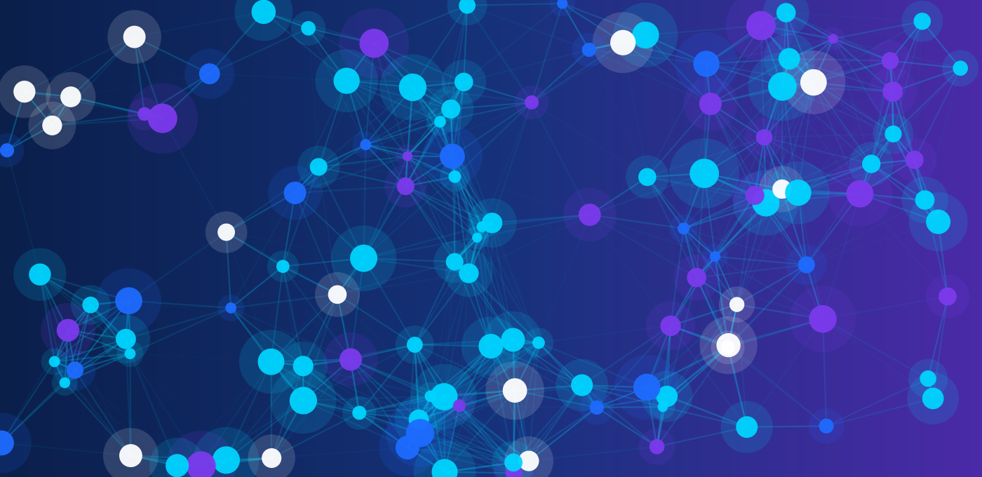
CLASS 11 | AI OLYMPIAD | MONTH 5
UNIT 5
AI TOOLS

AI Research Desk
AI Creation Studio
Student Workbook with worksheets, activities, puzzles, case studies, assessment and answer key
Name: ______________________________ Class: __________ Date: ______________
Use AI as a helper. Verify. Protect privacy. Credit honestly.
Table of Contents
Month 5 | Unit 5: AI Tools
How to Use This Workbook 3
PART A: AI Research Desk 4
Chapter 1: Introduction to AI Tools 4
Chapter 2: AI as Your Research Partner 6
Chapter 3: Writing Effective Prompts 8
Chapter 4: Summarising and Organising Research 11
Chapter 5: Verifying AI Output: Errors, Bias and Copyright 12
Chapter 6: Safe and Responsible Use of AI 16
Worksheet 1: AI Research Desk 19
PART B: AI Creation Studio 21
Chapter 7: Creative AI Tools for Text, Images and Stories 21
Chapter 8: Posters and Presentations with AI 23
Chapter 9: Human Creativity Plus AI Assistance 25
Case Study 1: Riya's Science-Fair Research 27
Case Study 2: The Class 11-B Awareness Poster 27
Worksheet 2: AI Creation Studio 29
PART C: Hands-On Practice Lab 31
Classroom Activities 31
Puzzles and Creative Challenges 31
Before-and-After Prompt Makeovers 31
Research Verification Activities 31
Mini-Project: AI-Assisted Research Report or Creative Presentation 41
Worksheet 3: Prompting, Verification and Responsible Use 43
Practice MCQ Bank 45
PART D: Review and Assessment 47
Quick Revision Quiz and Concept Map 47
Chapter Summaries 47
Glossary 47
Assessment (30 Marks) 47
Answer Key 45
Page numbers refer to the footer numbers. If you edit the workbook, update the numbers by hand.

How to Use This Workbook
Welcome to Month 5, Unit 5: AI Tools of the Class 11 AI Olympiad programme. This unit has two topics: AI Research Desk and AI Creation Studio. You will learn how to use AI tools to research, learn, create and present, and, just as importantly, how to check their work, protect your privacy and stay honest.

What you will be able to do
- Name the main categories of AI tools and match each to a real school task.
- Write clear prompts using Role, Instruction, Context, Format and Example, and improve them through testing.
- Use AI to summarise, organise, brainstorm and plan, then verify the results with reliable sources.
- Spot hallucinations, bias, copyright problems and other limits of AI tools.
- Create posters, stories and presentations with AI help while keeping your own ideas and voice.
- Follow safe, private and responsible habits whenever you use AI.

How the workbook is organised
Part | What is inside
Part A: AI Research Desk | Chapters 1 to 6 and Worksheet 1
Part B: AI Creation Studio | Chapters 7 to 9, two case studies and Worksheet 2
Part C: Hands-On Practice Lab | Five activities, four puzzles, prompt makeovers, verification tasks, a mini-project, Worksheet 3 and an MCQ bank
Part D: Review and Assessment | Revision quiz, concept map, chapter summaries, glossary, a 30-mark assessment and the full answer key

PLEASE READ: THREE GOLDEN RULES
1. AI is a helper, not a judge. Never treat an AI answer as automatically correct.
2. Protect privacy. Never type personal or confidential information into an AI tool.
3. Be honest. Say when AI helped you, and keep the final thinking your own.

NO INTERNET OR AI ACCOUNT? NO PROBLEM
Every activity has a simulated version (sample prompts, sample AI answers and fictional data) that you can complete offline. Tool names in this book are examples only. Tools change quickly: features, prices, age limits and free/paid plans vary, and some need an account. Use only tools approved by your school and parents or guardians.

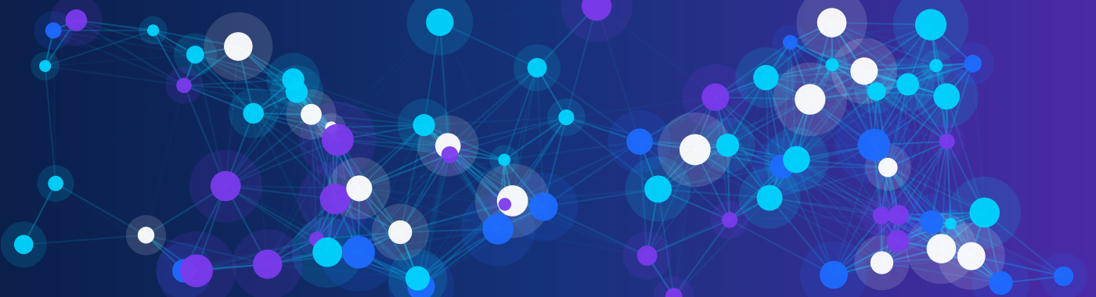
PART A

AI Research Desk
Use AI to explore, learn, summarise and organise, then check everything.
Chapter | Focus
1 Introduction to AI Tools | What AI tools are and the nine categories
2 AI as Your Research Partner | Research, brainstorming, learning and problem-solving
3 Writing Effective Prompts | Role, instruction, context, format, example, and revision
4 Summarising and Organising Research | Condensing sources and building notes
5 Verifying AI Output | Errors, hallucinations, bias, copyright and limits
6 Safe and Responsible Use of AI | Privacy, honesty and good habits

PART A IN ONE SENTENCE
The Research Desk teaches you to ask well, read critically and verify: the three skills that separate a smart AI user from a careless one.

Chapter 1: Introduction to AI Tools
An AI tool is software that uses artificial intelligence, usually machine learning, to do tasks that normally need human thinking: understanding language, spotting patterns, creating text or pictures, and making suggestions. You may already use some without noticing: autocorrect, voice assistants, video recommendations and photo filters are all AI at work.

Why do people use AI tools?
- Speed: get a first draft, outline or summary in seconds.
- Support: receive an explanation again and again in simpler words, at any hour.
- Variety: see many ideas, styles or examples quickly.
- Accessibility: translation, captions and read-aloud help more people take part.

The nine categories of AI tools
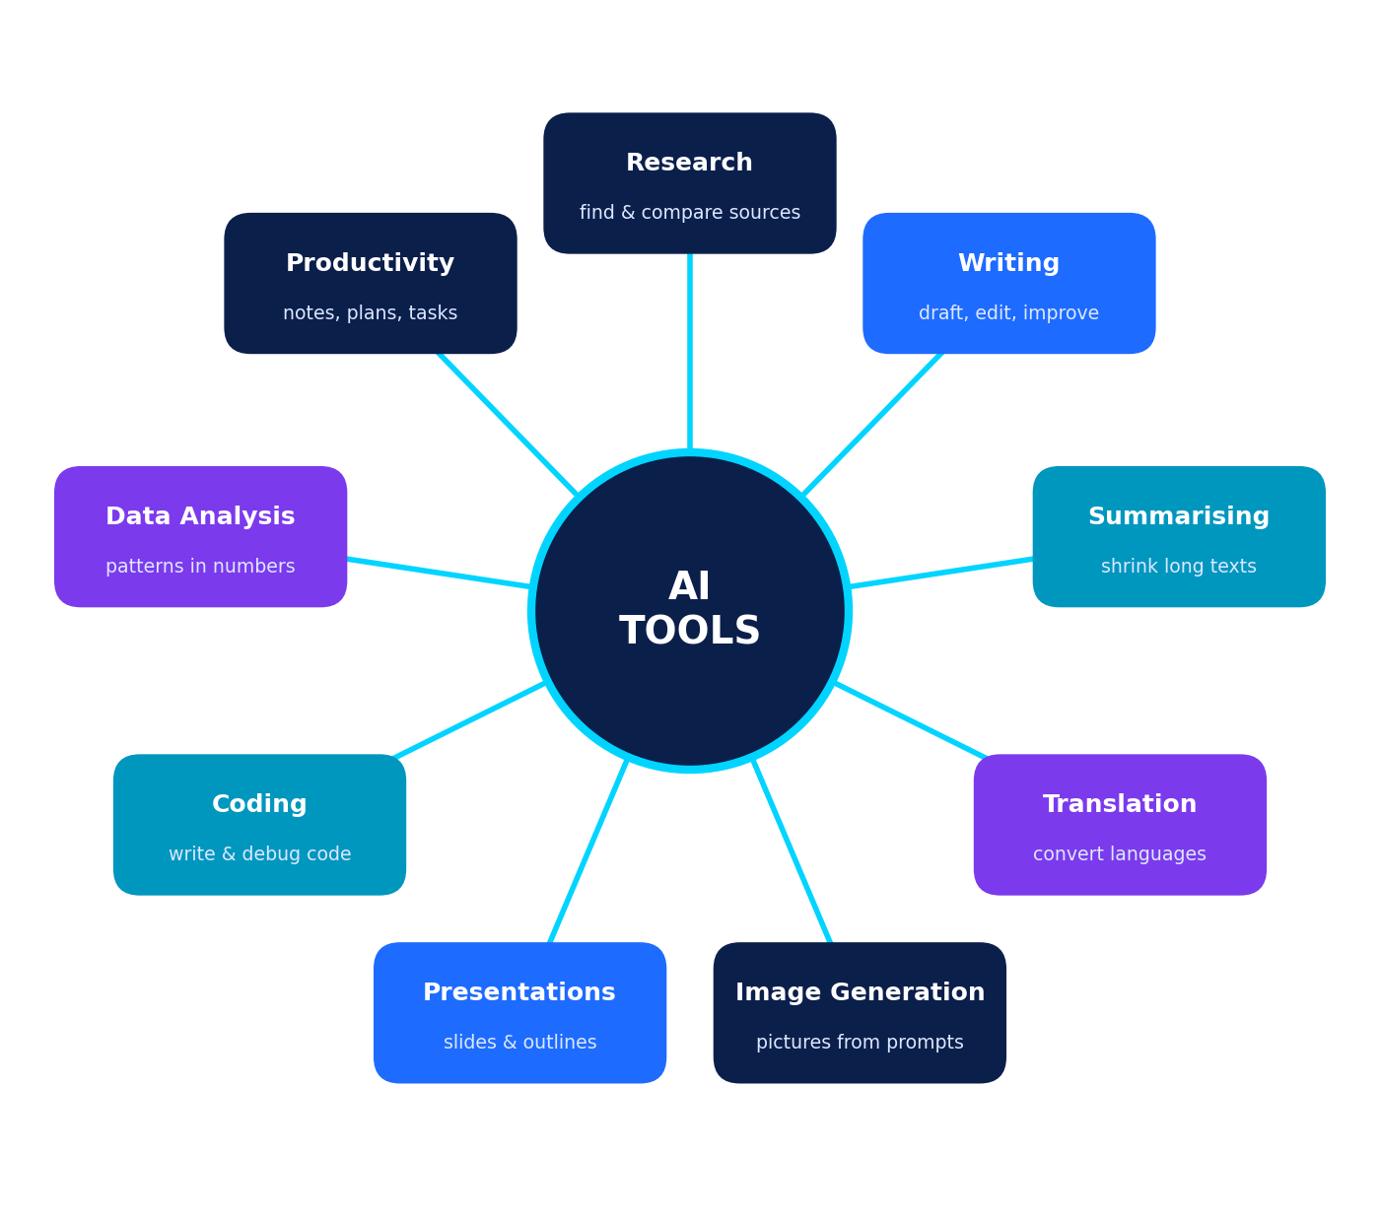
Figure 1.1: Nine categories of AI tools. Many tools combine several categories.
Category | What it does | Example school tasks | Example tools*
Research | Finds, explains and compares information; some tools show links to sources | Background on a topic; finding keywords and questions | AI search assistants (e.g. Perplexity), general chatbots
Writing | Drafts, rewrites and checks grammar and tone | Making a paragraph clearer; checking spelling | Chatbots (e.g. ChatGPT, Claude, Gemini), grammar assistants
Summarising | Condenses long text into key points | Turning a 10-page article into 5 bullets | Chatbots with file upload, NotebookLM
Translation | Converts text between languages | Understanding a source written in another language | Google Translate, DeepL
Image generation | Creates pictures from written descriptions | Illustration for a poster or story | Adobe Firefly, Canva AI tools, DALL·E, Midjourney
Presentation creation | Builds slide outlines and layouts | First draft of a 6-slide talk | Gamma, Canva, Copilot in PowerPoint
Coding | Suggests code, explains errors | Debugging a Python loop | GitHub Copilot, chatbots
Data analysis | Cleans data, makes charts, spots trends | Finding the average and trend in survey results | Spreadsheet AI features, chatbots with data upload
Productivity | Takes notes, plans, transcribes, organises | Meeting notes; a study timetable | Otter.ai, Notion AI, calendar assistants
*Names are examples only, not recommendations. Availability, features, prices and age limits vary, and some tools need an account or a paid plan. Always check your school's rules first.

How do AI chat tools work? (Simple version)
Most chatbots are built on a large language model (LLM). An LLM is trained on huge amounts of text and learns patterns about which words tend to follow which. When you type a prompt, it predicts a likely, fluent reply one piece at a time. This explains both its strengths (fluent writing, flexible answers) and its weaknesses: it can sound confident while being wrong, because it generates plausible text rather than looking up guaranteed facts. Some tools are connected to web search, which can help, but you must still check the sources.
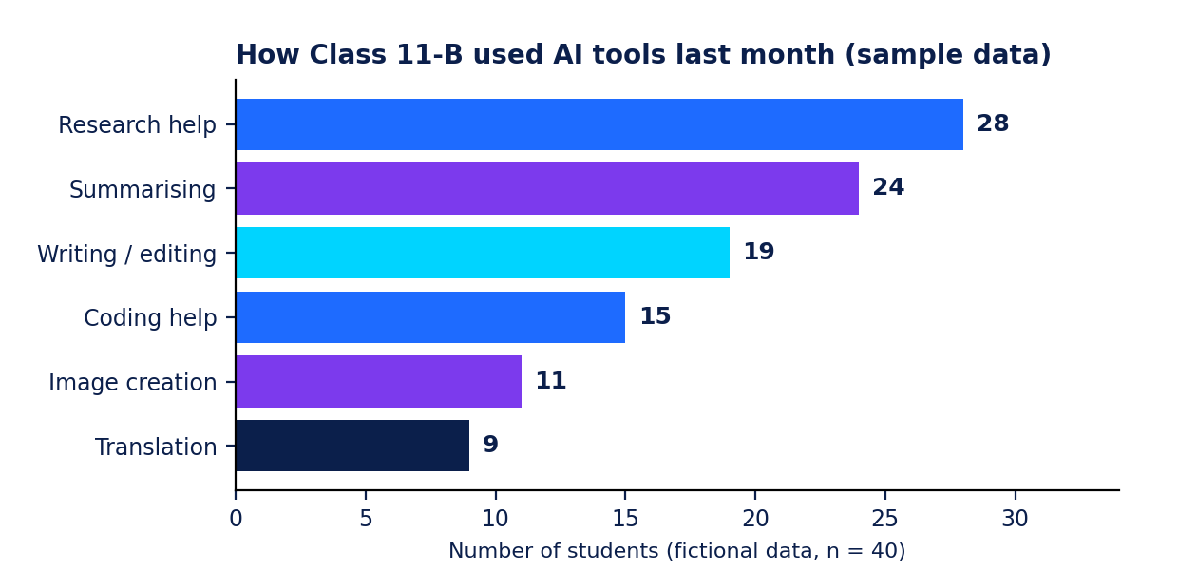
Figure 1.2: A sample chart. Data-analysis tools can turn a table of numbers into a chart like this (fictional data).
THINK AND WRITE
Look at Figure 1.2. Write two things the chart tells you and one question you would want to check before trusting it.

Chapter 2: AI as Your Research Partner
Think of an AI tool as a research desk assistant: quick, helpful and always available, but not an expert you can trust blindly. You are the researcher. You decide the question, judge the evidence and write the conclusion.

Four ways AI tools support your work
Support | How AI can help | Example prompt
Research | Suggests angles, keywords, background and questions to explore | "List 6 sub-questions I could research about rainwater harvesting in schools."
Brainstorming | Produces many ideas and different viewpoints to choose from | "Give 10 ideas for a Class 11 awareness campaign on e-waste."
Learning | Explains in simpler words, gives analogies, quizzes you | "Explain neural networks with an everyday analogy, then ask me 3 quiz questions."
Problem-solving | Breaks a problem into steps and checks your reasoning | "Here is my solution to this probability question. Check each step and tell me where I may have gone wrong."

The AI-assisted research workflow
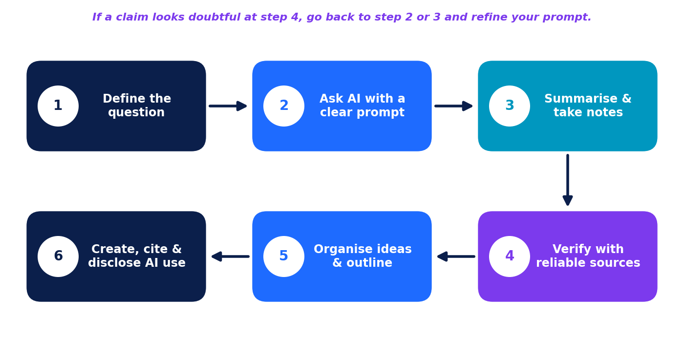
Figure 2.1: A six-step research workflow. Step 4 (verify) is never skipped.

Practical demonstration: researching rainwater harvesting
Meet Aarav (a fictional student in Class 11) who is preparing a school project: "Can our school collect rainwater?". Here is how he uses AI in steps.
Step | Aarav does this | Why it works
1 | Writes his question: "How can a school collect and use rainwater, and is it worth it?" | A clear question guides everything else.
2 | Prompt: "You are a science teacher. List 6 sub-questions a Class 11 student should research about school rainwater harvesting. Use a numbered list." | Role, task and format are clear.
3 | Picks 3 sub-questions (cost, method, benefits) and asks AI to explain each in simple words. | He chooses; AI supports.
4 | Looks up the claims in a government water-resources website and a university guide. | Verification with reliable sources.
5 | Notes down facts with the source name and date in a table. | He can cite properly later.
6 | Writes the report in his own words and adds: "AI assistance: question planning and explanation; all facts checked by me." | Honest disclosure.

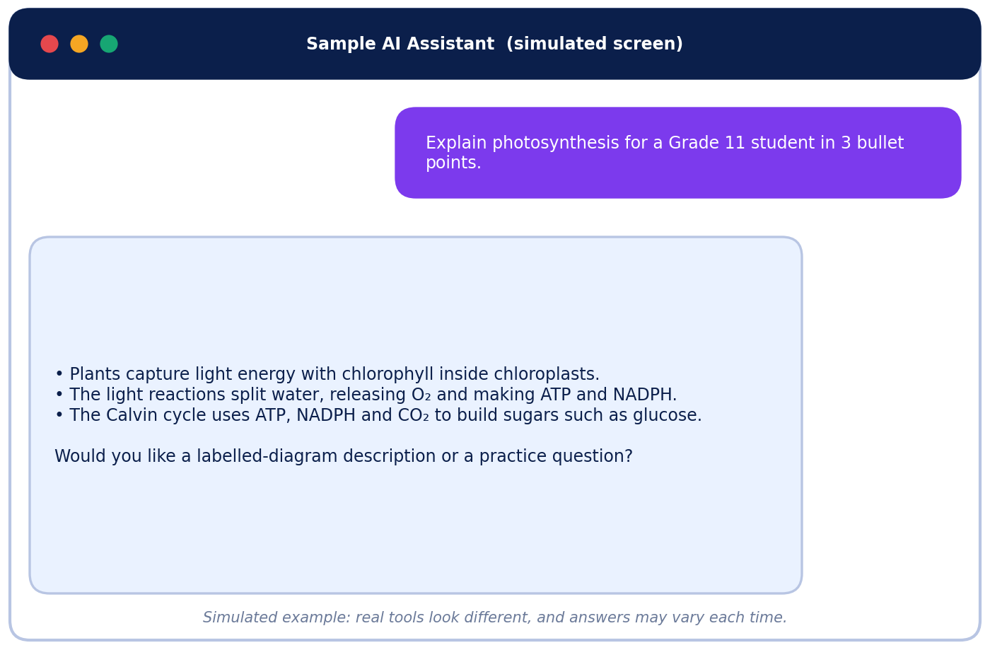
Figure 2.2: A simulated chat. The answer is helpful, but a student should still check it against a textbook.
AI CAN HELP, AI CANNOT REPLACE
AI can help you: start, plan, explain, compare, organise and practise.
AI cannot replace: your judgment, checking facts, ethical decisions, personal understanding and responsibility for your work.

TRY IT (LIVE OR SIMULATED)
Choose a topic from your own school subject. Write one prompt that would give you five sub-questions to research. Then circle which question you would research first and why.
Your prompt and your choice:

Chapter 3: Writing Effective Prompts
A prompt is the instruction or question you give an AI tool. The quality of your prompt strongly affects the quality of the answer. Vague prompt, vague answer. Clear prompt, useful answer.

The 5-part prompt
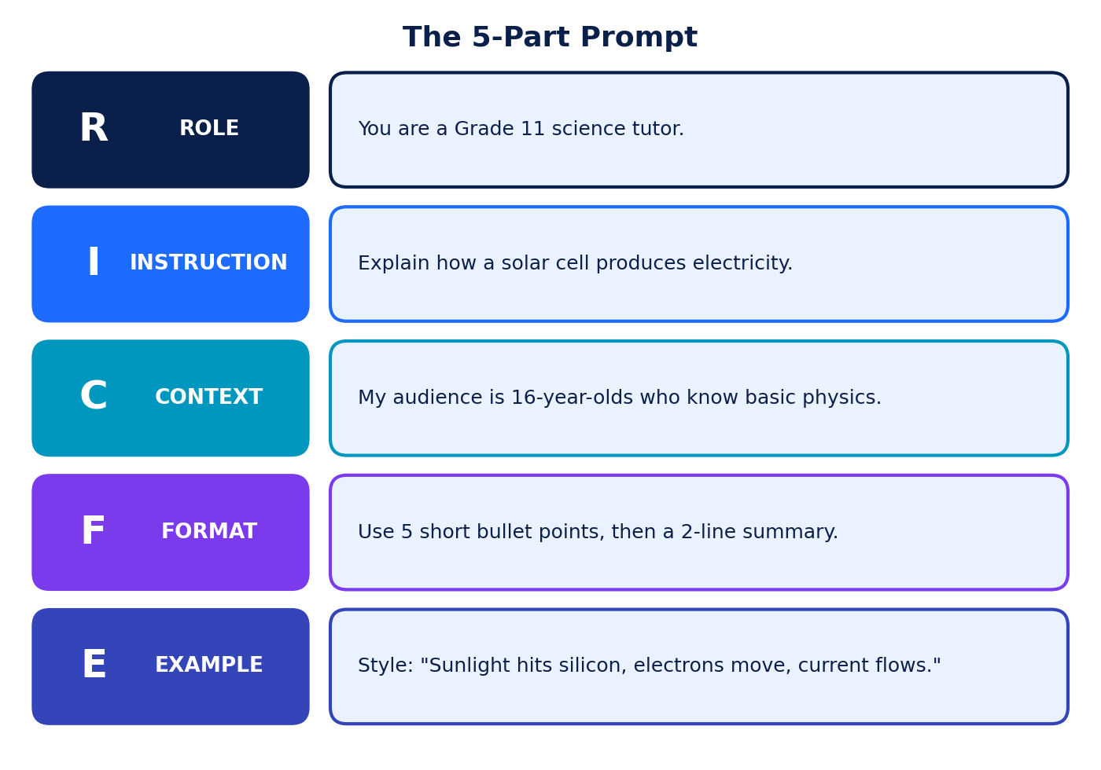
Figure 3.1: The five parts of a strong prompt.
Part | Question it answers | Weak | Strong
Role | Who should the AI act as? | (none) | "You are a Grade 11 science tutor."
Instruction | What exactly should it do? | "About solar." | "Explain how a solar cell produces electricity."
Context | Who is it for? What do you already know? | (none) | "For 16-year-olds who know basic physics."
Format | What shape should the answer take? | (none) | "5 bullet points and a 2-line summary."
Example | What does a good answer look like? | (none) | "Style: Sunlight hits silicon, electrons move, current flows."

A COMPLETE PROMPT
You are a Grade 11 science tutor. Explain how a solar cell produces electricity. My audience is 16-year-olds who know basic physics. Use 5 short bullet points followed by a 2-line summary. Keep the style simple, like: "Sunlight hits silicon, electrons move, current flows."

Useful prompt patterns
- Explain simply: "Explain ___ as if to a Class 8 student, then as if to a Class 12 student."
- Compare: "Compare ___ and ___ in a table with 3 criteria."
- Step by step: "Show the steps to solve ___ and explain each step."
- Ask me first: "Before answering, ask me 3 questions to understand what I need."
- Show uncertainty: "If you are not sure about a fact, say so and tell me how to check it."
- Practise: "Quiz me with 5 questions on ___. Wait for my answers before correcting."

Before and after
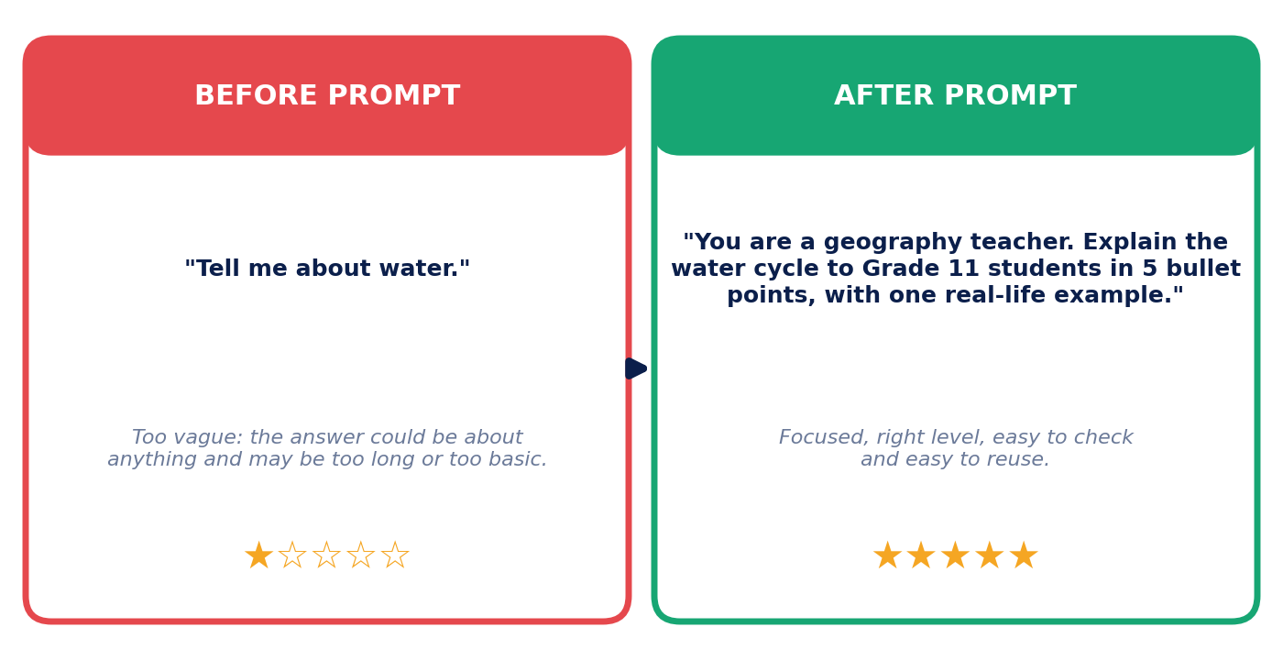
Figure 3.2: Same topic, very different usefulness.

Improving prompts through testing and revision
Professional prompt writers rarely get a perfect answer first time. They test, evaluate and revise.
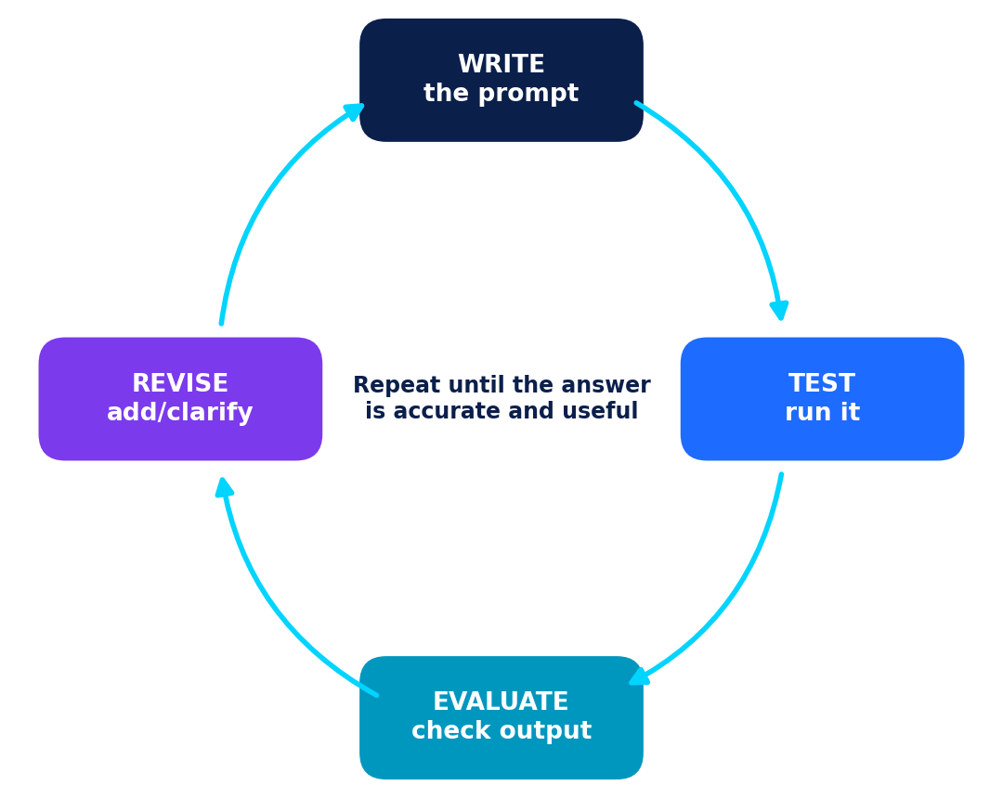
Figure 3.3: The prompt improvement loop.
Version | Prompt | What happened | Next change
v1 | "Explain machine learning." | Too technical and very long. | Add audience and length.
v2 | "Explain machine learning to a Class 9 student in 100 words." | Better, but no example. | Ask for an everyday example.
v3 | "You are a friendly teacher. Explain machine learning to a Class 9 student in about 100 words, using an example of how a phone suggests photos. End with one question to check understanding." | Clear, short, relevant. Checked facts with textbook: correct. | Save as a template.

PROMPT CHECKLIST
Is my goal clear? Did I give role, context and format? Did I set length? Did I ask the AI to flag uncertainty? Did I avoid personal information? Did I plan to verify the answer?

PRACTICE: BUILD A PROMPT
Topic: How to prepare for a Class 11 Olympiad exam. Write a prompt with all five parts.
Role: Instruction: Context: Format: Example:

Chapter 4: Summarising and Organising Research
Research often means reading more than you can handle. AI tools can shrink long texts and sort your notes, which gives you time to think. But a summary is only as good as its match with the original, so you must always compare.

Choose the right kind of summary
Type | What it looks like | Prompt starter
One-line | A single sentence capturing the main point | "Summarise this text in one sentence."
Bullet points | 3 to 6 key points | "Give the 5 most important points as bullets."
Short paragraph | About 50 to 100 words | "Write a 60-word summary for a Class 11 reader."
5W + H | Who, What, When, Where, Why, How | "Answer who, what, when, where, why and how from this text."
For an audience | Same facts, different level | "Summarise for a Class 6 student, then for a teacher."

Practical demonstration: checking an AI summary
ORIGINAL TEXT (FICTIONAL)
Greenfield City, a fictional coastal town, began a rooftop garden programme in 2021. By 2024, 35 public buildings had planted vegetable and herb gardens on their roofs. City officials say the gardens keep roofs cooler in summer and give schools fresh produce for meal programmes. A survey of 200 residents found that most supported the programme, though some worried about the cost of maintenance. Engineers stress that each roof must be checked for strength before planting. The programme will add ten more buildings in 2026, depending on funding.

SIMULATED AI SUMMARY
Greenfield City has built gardens on 53 public buildings since 2021, cutting summer temperatures by 5 °C. Residents love the idea, and ten more gardens are planned for 2026.

Your task: compare the summary with the original. Find at least three problems (wrong detail, added information, missing important point, or changed meaning).
Problems I found:
WHY SUMMARIES GO WRONG
AI summaries can change numbers, add details that were never in the text, drop warnings or cautions, and make mixed opinions sound one-sided. A summary helps you start; it does not replace reading the original.

Organising research with AI
After collecting information, you need to arrange it. Try this routine:
- Collect your notes in a table (key point, evidence, source, date).
- Cluster similar points into 3 or 4 themes.
- Label each theme with a short heading.
- Order the themes into an outline (introduction, main points, conclusion).
- Find gaps: what is missing or one-sided?

Source (fictional) | Key point | Evidence | Reliability | Quote or paraphrase?
City Parks Dept report, 2024 | 35 buildings have rooftop gardens | Official count | High (official body) | Paraphrase
Resident survey, 2023 | Most of 200 residents support gardens | Survey data | Medium (small sample) | Paraphrase
Local blog post | Gardens cut energy bills by half | No data given | Low (no evidence) | Do not use

A SAFE ORGANISING PROMPT
Here are my notes (pasted below). Group them into 3 or 4 themes, give each theme a title, and list any gaps. Do not add new facts.

Generating ideas: diverge, then converge
Brainstorming has two phases. Diverge: ask AI (and your team) for many ideas without judging. Converge: choose the best using clear criteria. AI is good at the first phase. You and your team must lead the second.
Idea | Feasible (1-5) | Creative (1-5) | Impact (1-5) | Total
Idea A: Waste-sorting quiz game | 4 | 3 | 4 | 11
Idea B: Short podcast on e-waste | 3 | 4 | 3 | 10
Idea C: Poster series with QR facts | 5 | 3 | 4 | 12
The idea with the highest total (C) is chosen, but the team may still adjust for budget and time.

Chapter 5: Verifying AI Output: Errors, Bias and Copyright
AI tools are impressive, and they are also fallible. A good student knows the common problems and checks every important claim before using it.
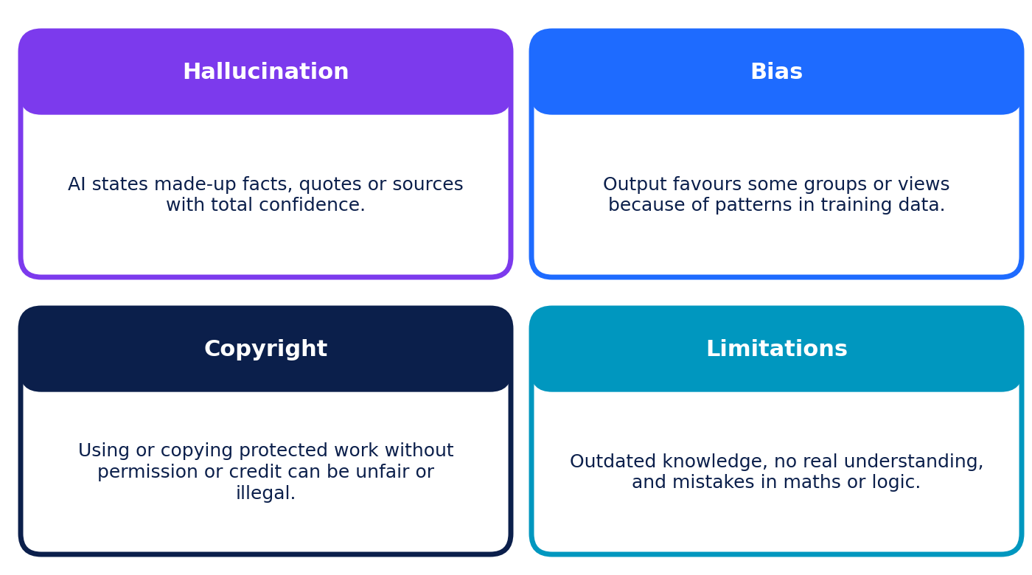
Figure 5.1: Four big issues to remember.

Common AI errors
Error type | What it looks like | Example (fictional)
Hallucination | Invented facts, quotes, names or sources stated confidently | A "study" with a real-sounding title that does not exist
Outdated information | Answers based on old training data | Describing a "current" record that has since changed
Maths or logic slip | Wrong calculation or reasoning step | Finding 15% of 80 as 14
Over-simplification | Leaves out exceptions or conditions | "All metals are solid at room temperature" (mercury is liquid)
Fake citations | Real-looking references that cannot be found | A DOI that opens nothing
Overconfidence | No hint of uncertainty | "Definitely" used for a debated topic

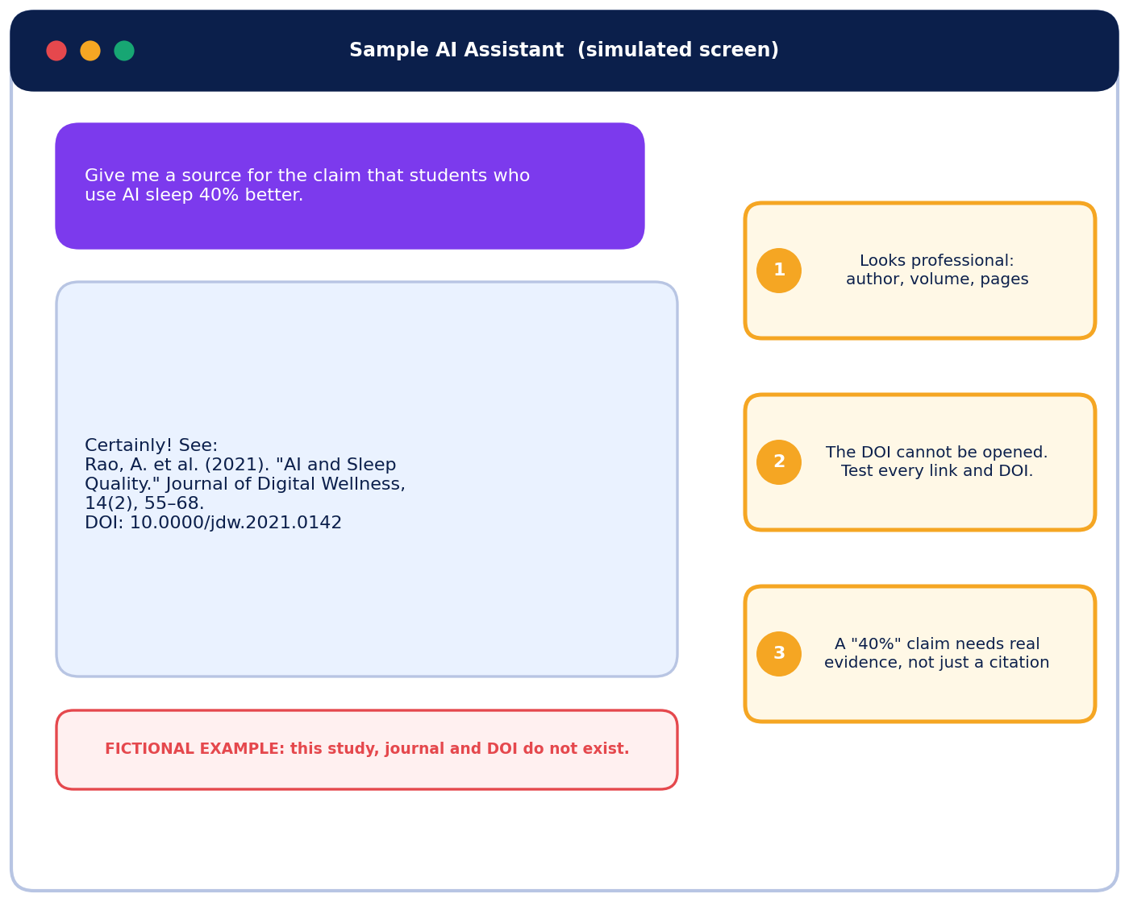
Figure 5.2: A simulated hallucination. The reference looks real but was invented for this workbook.

The C.H.E.C.K. method
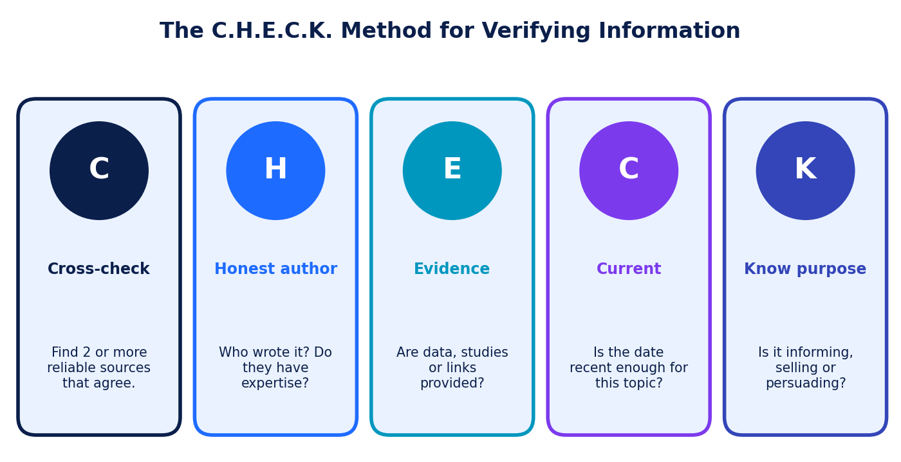
Figure 5.3: Five quick questions for any claim.

Which sources should you trust?
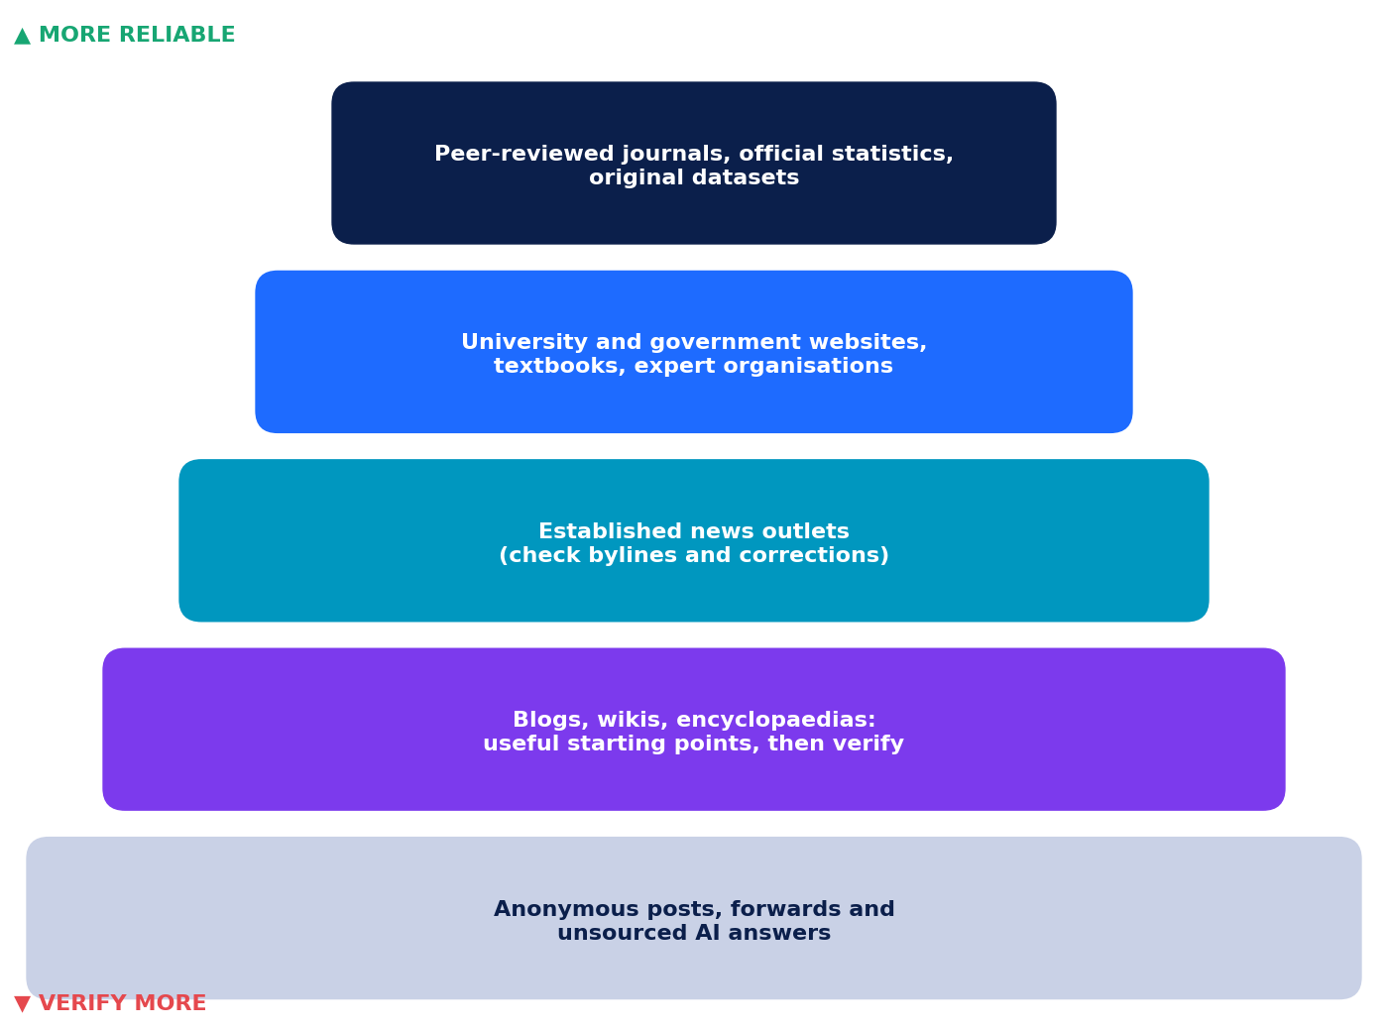
Figure 5.4: Source reliability. Higher is usually more reliable, but check every source.
Green flags (more reliable) | Red flags (less reliable)
Named author with relevant expertise | No author, or a fake-sounding name
Publication date and updates shown | No date, or very old for a fast-changing topic
Links to data, studies or official documents | Dramatic claims, no evidence
Corrections policy; balanced tone | Pushes you to share or buy; emotional language
Other reliable sources say the same | Only one source (or only social media) says it

LATERAL READING
Do not stay on one page. Open new tabs and search for the author or organisation. What do other reliable sources say about them? This takes two minutes and catches many fakes.

Primary sources come directly from the creator or data collector (a census table, an interview, an original experiment report). Secondary sources explain or analyse primary sources (textbooks, news analysis). Use primary sources for key facts when you can.

Bias in AI output
Bias means output that is systematically unfair or one-sided. It can come from (1) training data that over-represents some groups or views, (2) design choices made by builders, and (3) your own prompt, if it is leading.
Biased or leading prompt | Better prompt
"Why is online learning better than classroom learning?" | "Compare online and classroom learning: give two advantages and two limits of each."
"Describe a typical engineer." | "Describe five engineers with different backgrounds and specialities. Avoid stereotypes."
To reduce bias: ask for several perspectives, check who or what is missing, compare with diverse reliable sources, and question stereotypes.

Copyright, plagiarism and fair credit
Copyright protects original creative work (writing, art, music, photos, code) from being copied or used without permission. It protects the expression of an idea, not facts or ideas themselves. Plagiarism is presenting someone else's work or words as your own. AI adds new questions: AI output may resemble existing work, and the rules about who owns AI-generated content and how training data may be used differ by country and are still changing. So the safe approach is: use your own words and ideas, use licensed or open material, give credit, and follow your school's AI policy.
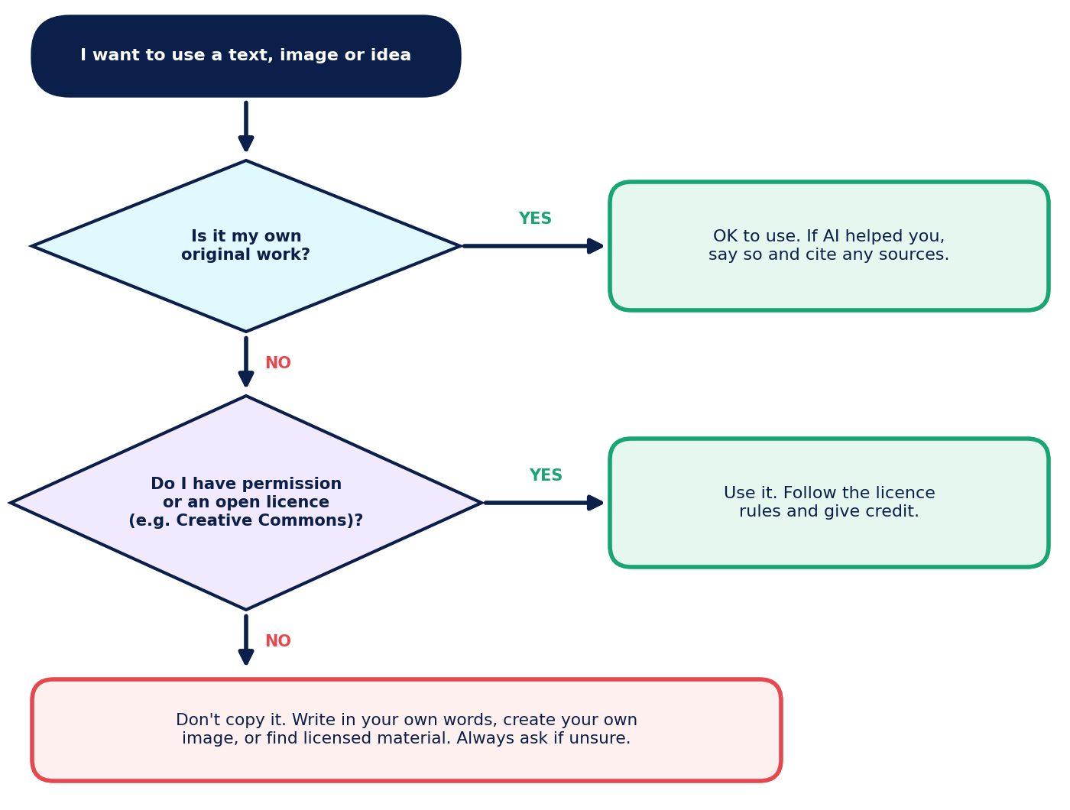
Figure 5.5: A simple "Can I use this?" flowchart.

Limitations of AI tools
- Knowledge cutoff: training data ends at a certain date, so recent events may be missing unless the tool searches the web.
- No real understanding: tools predict patterns; they do not truly "know" or feel.
- Inconsistency: the same prompt can give different answers on different tries.
- Limited context: very long inputs may be partly ignored.
- Cannot check itself reliably: asking "Are you sure?" does not prove correctness.
- Access varies: features, free limits and age rules change.

Chapter 6: Safe and Responsible Use of AI
Using AI responsibly means protecting yourself and others, being honest about AI help and following the rules of your school and the platform.

Privacy: what to share, what to keep out
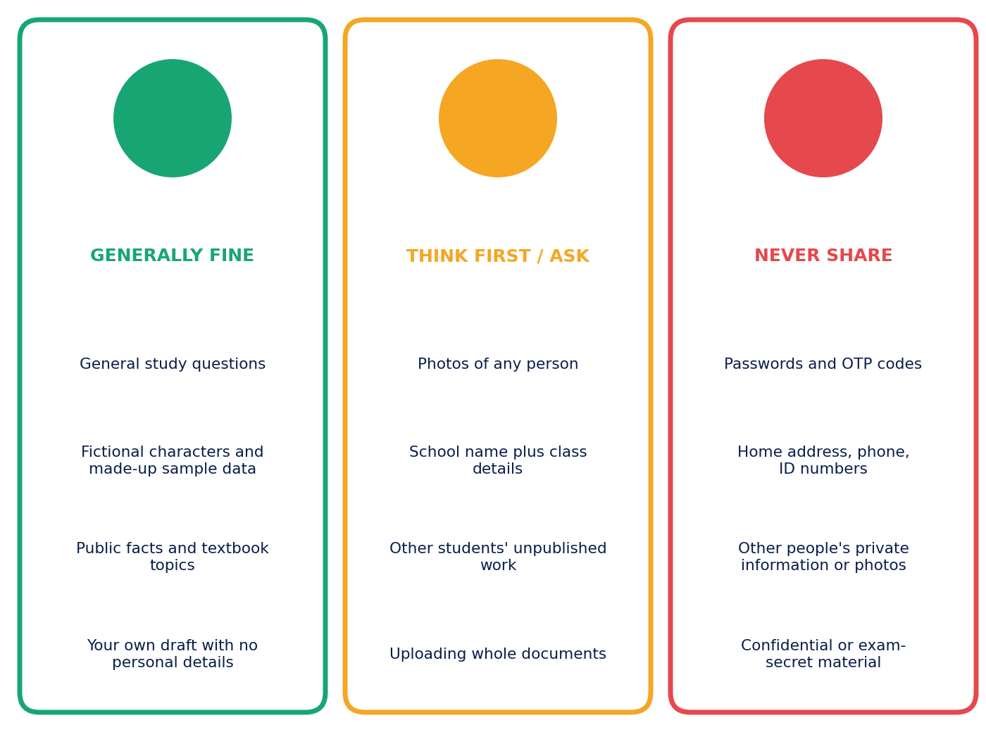
Figure 6.1: The privacy traffic light.
Assume that anything you type into an online tool may be stored or reviewed, depending on the tool and its settings. Read the privacy information or ask a teacher. Use placeholders instead of real details.
Unsafe prompt | Safer prompt
"I am Riya Sharma, 12 Park Road, phone 98xxxxxx. Write a complaint letter about my school bus." | "Write a polite complaint letter from a student to a school transport manager about a late bus. Use [Student Name] and [School] as placeholders."
(Uploading a photo of a classmate to get a cartoon version) | "Create a cartoon of a fictional student with a blue backpack."

Responsible habits
- Use approved tools. Follow your school's rules and age requirements; ask a parent or teacher if unsure.
- Protect accounts. Use strong, unique passwords and never share them or one-time codes.
- Respect others. Do not create or share fake, harmful or embarrassing content about real people (including AI-edited photos, voices or videos).
- Stay honest. Follow assignment rules, add an AI-use note, and never submit AI work as entirely your own.
- Think about fairness. Does your use of AI treat people fairly and leave out no group?
- Know when not to use AI. If the goal is to practise a skill (such as solving a problem yourself), doing it with AI may defeat the purpose.
AI-USE DISCLOSURE (SAMPLE)
"AI assistance: I used an AI chatbot to brainstorm questions and to suggest a slide order. I checked all facts using the sources listed and wrote the final text myself."

MY RESPONSIBLE AI PLEDGE
Complete the three sentences and sign.
I will always... / I will never... / When I am unsure, I will... Signature: ________________

Worksheet 1: AI Research Desk
Name: | Class / Section: | Date:

Time: 35 minutes. Answer all 14 questions. Write answers in the boxes provided.
Section A: Multiple Choice 1 mark each
Q1. Which AI tool category is mainly designed to turn a long article into a short overview?
A. Translation | B. Summarisation
C. Image generation | D. Coding
Q2. In the 5-part prompt, which part tells the AI who it should act as?
A. Role | B. Format
C. Example | D. Context
Q3. An AI answer gives a very specific statistic but no source. What is the best next step?
A. Use it, because specific numbers are always correct | B. Ask the AI if it is sure and accept "yes"
C. Look for the figure in a reliable source such as official statistics | D. Round the number up
Q4. Which of these is safest to type into a public AI chatbot?
A. Your home address | B. A classmate's phone number
C. A question about how photosynthesis works | D. Your school login password

Section B: Fill in the Blanks 1 mark each
Q5. A wrong or invented answer that an AI presents confidently is called a ____________________.
Q6. Improving a prompt by testing it, checking the output and rewriting it is called prompt ____________________.
Q7. Unfair or one-sided output caused by patterns in the training data is called AI ____________________.

Section C: True or False 1 mark each
Q8. AI summaries should always be compared with the original text. True / False
Q9. If a chatbot gives a reference with a DOI, the source must exist. True / False
Q10. A prompt with role, context and format usually gets a more useful answer than a one-word prompt. True / False

Section D: Match the Following 1 mark each
Q11. Match each AI tool category (left) with its best task (right). Write the letter.
Category | Letter | Task
1. Translation |  | a. Producing an illustration from a text description
2. Coding |  | b. Finding the average and trend in a table of marks
3. Data analysis |  | c. Suggesting a fix for an error in a Python program
4. Presentation creation |  | d. Turning an English paragraph into Hindi
5. Image generation |  | e. Creating slide layouts from an outline

Section E: Short Answer
Q12. List three ways AI tools can support research. (3 marks)
Q13. Improve this weak prompt by adding role, context and format: "Tell me about climate." (3 marks)
Q14. Explain why you should not paste a classmate's personal details into an AI tool. (2 marks)

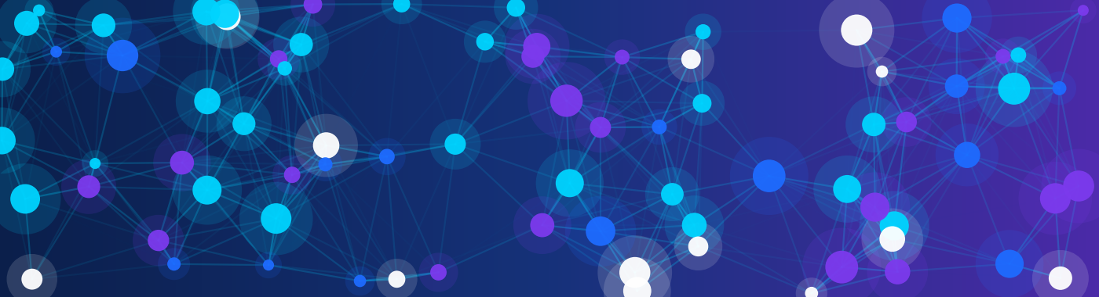
PART B

AI Creation Studio
Create posters, stories and presentations with AI, while staying original and honest.
Chapter | Focus
7 Creative AI Tools for Text, Images and Stories | Writing, image prompts and educational projects
8 Posters and Presentations with AI | Design basics, storyboards and slide creation
9 Human Creativity Plus AI Assistance | Working as a team with AI and sharing credit
Case Studies 1 and 2 | Useful and responsible AI in real-style situations
Worksheet 2 | Practice questions on the Creation Studio

PART B IN ONE SENTENCE
The Creation Studio is where your ideas lead and AI helps you try, draft and polish; you stay the author, editor and fact-checker.

Chapter 7: Creative AI Tools for Text, Images and Stories
Generative AI creates new content (text, images, audio or video) from your prompt. In school, creative AI tools can spark ideas, produce first drafts, and make visuals for stories, posters and projects. The creative direction should always be yours.

Writing and storytelling with AI
Text tools can suggest plots, characters, settings, dialogue and rewrites in different tones. Here is a demonstration (the AI reply is simulated).
PROMPT
You are a science-fiction author. Write a 4-sentence story opening about a Class 11 student who finds a robot in the school library. Tone: mysterious but kind.

SIMULATED AI DRAFT
The library lights flickered at 4:47 p.m., just as Meera reached for the last book on the shelf. Behind it, something metallic blinked. "Please do not shout," whispered a small robot. "I only wanted to read."

Editing question | Example human improvement
Is it specific and original? | Replace the generic start with a detail from your own school, such as the squeaky third-floor staircase.
Does it sound like me? | Rewrite the dialogue the way your characters would really speak.
Is anything clichéd or unrealistic? | Change "flickered" if you have read it a hundred times; find a fresher image.
Is it consistent? | Check names, time and facts across the story.
Is it fair and kind to others? | Avoid stereotypes and real people's names.

Creating images with AI
Image generators turn a written description (an image prompt) into a picture. The more precisely you describe it, the closer the result.
Element | Question | Example
Subject | What is in the picture? | a friendly robot teacher and three students
Setting | Where is it? | in a bright modern classroom
Style | What art style? | flat vector illustration
Mood | What feeling? | warm, curious
Colours | Which palette? | navy blue, cyan and violet
Composition | Where do things go? | empty space at the top for a title
Avoid | What to leave out? | no text, no logos, no real people

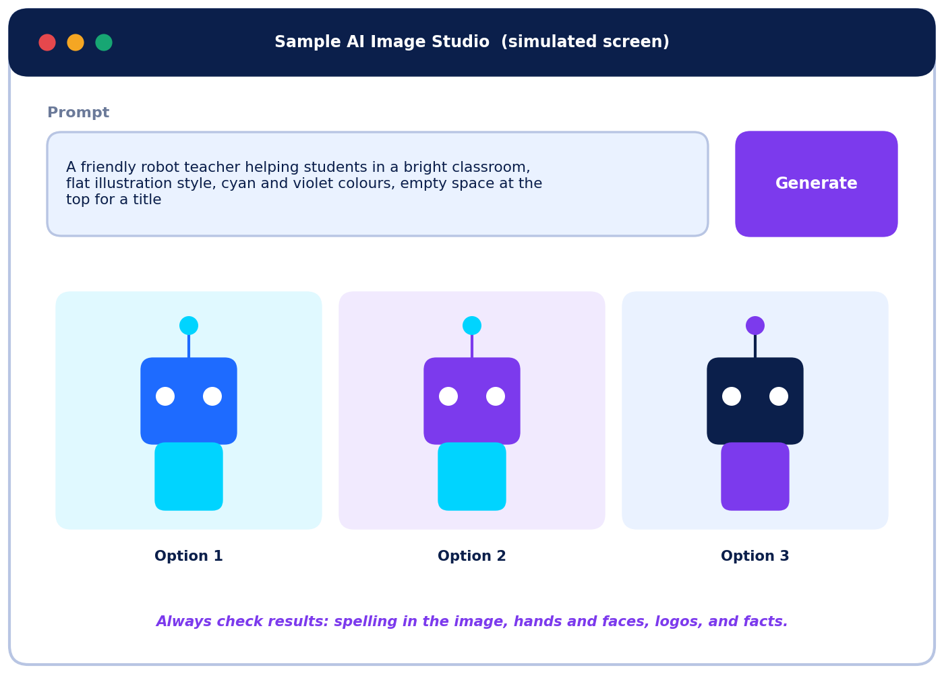
Figure 7.1: A simulated image studio. Real tools differ, and each try gives different results.
Weak image prompt | Improved image prompt
"a robot" | "A friendly robot teacher helping three students at a desk, bright classroom, flat vector style, navy, cyan and violet colours, warm mood, empty space at the top, no text."

CHECK EVERY AI IMAGE
Look for garbled or misspelt text, odd hands or faces, objects merged together, wrong cultural details and stereotypes. Do not ask for real people's faces, brand logos or copyrighted characters. If an image could mislead people, label it as AI-generated.

Educational projects you can create
Project | How AI can help | Your job
Infographic | Suggests structure and icons; makes illustrations | Choose and verify the facts; design clearly
Quiz or flashcards | Drafts questions and answer options | Check every answer is correct and fair
Timeline | Lists key events in order | Verify dates with reliable sources
Illustrated storybook | Gives plot ideas and pictures | Write the final story in your voice
Study guide or mind map | Groups topics and suggests links | Make sure the content matches your syllabus
Class podcast script | Drafts an outline and questions | Rehearse and add personal insight

Chapter 8: Posters and Presentations with AI

Designing a poster
A strong poster has one clear message that can be understood in about five seconds. AI can offer slogan ideas, image options and layout suggestions, and you choose, combine and edit.
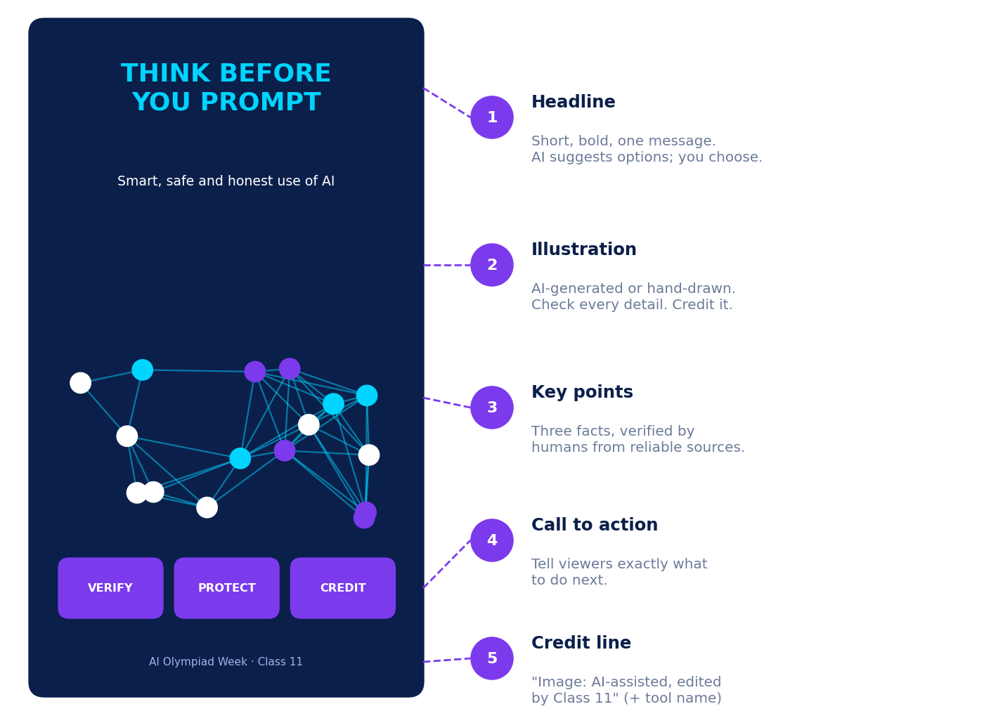
Figure 8.1: An annotated poster mock-up (simulated design).
Design principle | Quick guide
Hierarchy | Biggest = most important (headline), then key points, then details
Contrast | Dark text on a light background or light text on dark; check readability from 2 metres
Fonts | Use at most two; keep them easy to read
White space | Leave breathing room; avoid crowding
Call to action | Say what viewers should do next
Credit | Add sources and an AI-use credit line

Creating a presentation
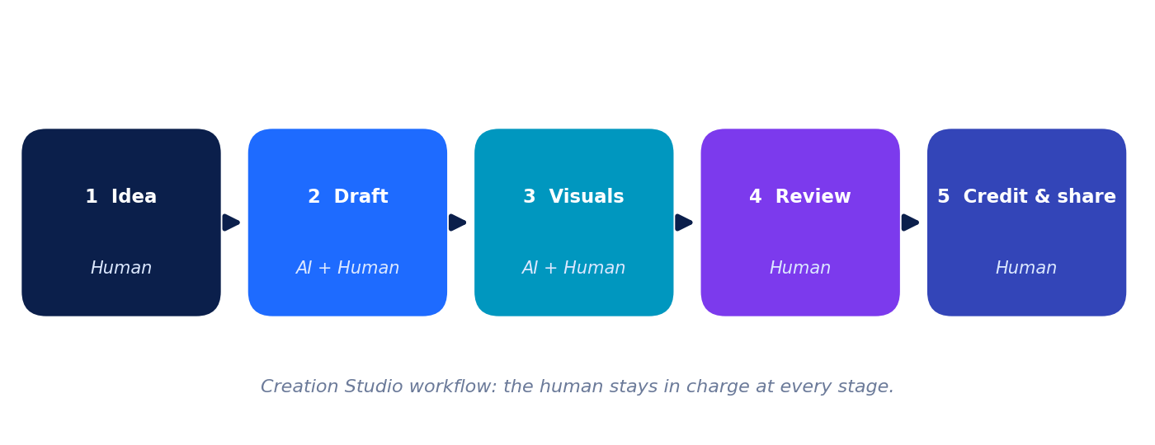
Figure 8.2: Creation workflow for a presentation or poster.
Presentation tools can turn an outline into slides, suggest layouts and write speaker-note drafts. Start with your message and audience, then use AI to speed up the steps.
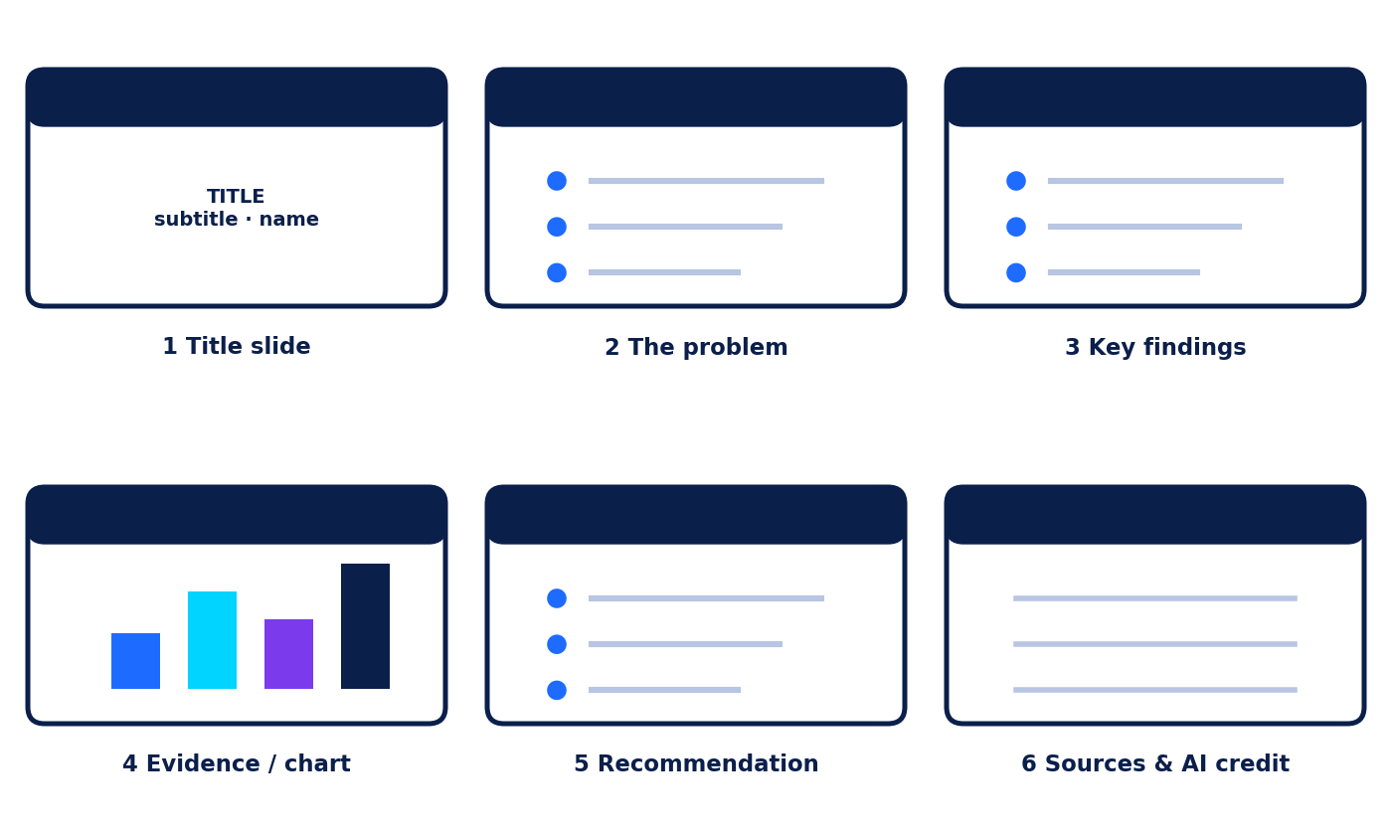
Figure 8.3: A six-slide storyboard (plan before you build).
PROMPT FOR A SLIDE OUTLINE
You are a presentation coach. Create a 6-slide outline for a 5-minute talk to Class 11 students on "Safe and Smart Use of AI". For each slide give a title, one key message and a suggested visual. Keep each message under 15 words.

Slide | Title | Key message | Visual idea
1 | Safe and Smart AI | AI helps best when we use it wisely | Cover with network art
2 | Why it matters | AI is everywhere, so habits matter | Photo-style icons of phone, laptop, camera
3 | Protect your privacy | Keep personal details out of prompts | Traffic-light graphic
4 | Check before you trust | Verify claims with reliable sources | C.H.E.C.K. cards
5 | Be honest and fair | Credit AI help; avoid bias and copying | Two-column do and don't table
6 | Sources and credits | Cite sources and AI-use note | List with logos removed

SLIDE-QUALITY CHECKLIST
One idea per slide. Few words and large text. High contrast. Charts labelled with units. Alt text for images. Facts verified. A final slide with sources and an AI-use note.

Chapter 9: Human Creativity Plus AI Assistance
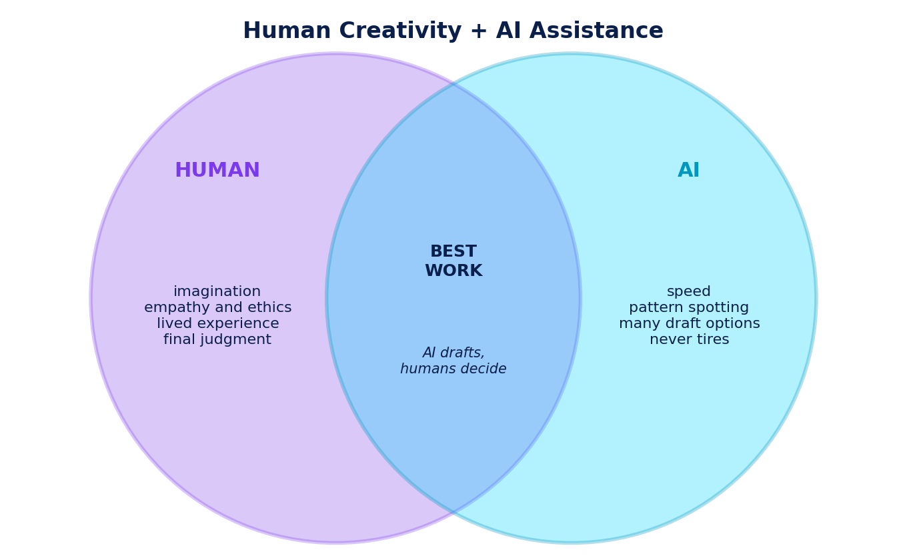
Figure 9.1: Humans and AI each bring different strengths.
The best results come from collaboration. Think of the AI sandwich: (1) You form the idea, goal and criteria; (2) AI provides options, drafts or feedback; (3) You edit, verify and decide.
Task | Human leads | AI can assist
Choosing the message | Decide what matters and why | Suggest angles
First draft | Outline in your own words | Offer an alternative outline or phrasing
Visual style | Decide the look and feel | Generate options
Fact-checking | Do it yourself with reliable sources | Suggest what to verify and where
Final judgment | Decide fairness, tone and ethics | None: this stays human
Credit | State AI use honestly | None

Keep your own voice
- Try your own first idea before you ask AI, so AI does not anchor your thinking.
- Ask AI to critique your draft rather than rewrite it.
- Mix ideas from several sources, including people, and add your own experience.
- Keep a short creativity log: what was my idea, what did AI add, what did I change?

Practical examples for school projects and AI Olympiad tasks
Situation | Sensible AI use | Human responsibility
Science fair report | Plan questions, explain methods, suggest chart types | Run the experiment, record real data, verify facts
History project | Create a timeline draft, summarise sources | Check dates and sources, write interpretation
Debate preparation | Generate arguments for both sides | Evaluate evidence, build your own case
Coding club task | Explain an error message, suggest test cases | Understand the fix, test and document your code
AI Olympiad prompt round | Test prompt versions and compare outputs | Explain why one prompt is better
Ethics scenario round | Collect viewpoints to consider | Reach and justify your own decision

REFLECT
Describe one school task in which you would use AI and one in which you would deliberately not use AI. Explain both choices.

Case Study 1: Riya's Science-Fair Research
FICTIONAL CASE: USEFUL AND RESPONSIBLE AI
Riya (a fictional Class 11 student) is researching "Does background music affect memory?" for her school science fair.

- Planning: Riya asks an AI chatbot for sub-questions, a simple experiment design, and an explanation of "control group".
- A warning sign: The chatbot cites a "2018 Mumbai University study" with an exact percentage. Riya cannot find it in any library search, so she drops the claim and uses a psychology textbook from the school library instead.
- Data: She surveys 30 classmates anonymously (codes, not names) and uses a spreadsheet assistant to create a chart. She checks the average herself.
- Privacy: She never types classmates' names or photos into any tool.
- Honesty: Her report ends with an AI-use note and a sources list.

Analyse the case
1. Give two useful ways Riya used AI. (2 marks)
2. What kind of AI error did she meet, and how did she handle it? (2 marks)
3. Name two privacy-safe choices she made. (2 marks)
4. What else could Riya do to verify the textbook's information? (2 marks)

Case Study 2: The Class 11-B Awareness Poster
FICTIONAL CASE: CREATIVITY, BIAS AND COPYRIGHT
A group of four students in Class 11-B (fictional) makes a poster for Digital Wellbeing Week.

- Ideas: They ask AI for 10 slogans, shortlist three, vote, and combine two into their own line.
- Images: The generator's first pictures show only boys as "coders". The team notices the bias and rewrites the prompt to show a mix of students.
- Errors: One image has garbled text. They remove it and add the heading in their design tool.
- Copyright: A teammate wants a famous cartoon character. They decide not to copy it and design an original mascot instead.
- Privacy: They use only fictional students, never classmates' photos.
- Credit: The poster's footer reads: "Illustration: AI-assisted, edited by Class 11-B."

Analyse the case
1. How did the team show human creativity in the project? (2 marks)
2. Explain how they dealt with bias in the images. (2 marks)
3. Why was avoiding the cartoon character a good decision? (2 marks)
4. Suggest one more step the team could take before printing the poster. (2 marks)

Worksheet 2: AI Creation Studio
Name: | Class / Section: | Date:

Time: 35 minutes. Answer all 14 questions.
Section A: Multiple Choice 1 mark each
Q1. What is the best use of an AI image generator for a school poster?
A. Copying a famous artist's picture exactly | B. Creating an original illustration from a clear description and noting the AI use
C. Making an image of a real classmate without permission | D. Using the first image without checking it
Q2. Which part of making a presentation does AI usually help with most quickly?
A. Taking responsibility for accuracy | B. Knowing the audience personally
C. Drafting a first slide outline | D. Making the final ethical judgment
Q3. Which action shows responsible human and AI collaboration?
A. Submitting AI text unchanged as your own work | B. Using AI for ideas, then writing, editing and fact-checking yourself and noting AI help
C. Letting AI choose all the facts | D. Hiding that AI was used

Section B: Fill in the Blanks 1 mark each
Q4. A written description given to an image generator is called an image ____________________.
Q5. Telling readers which tool helped you is called ____________________ AI use.
Q6. A rough plan showing the order of slides is called a ____________________.

Section C: True or False 1 mark each
Q7. AI-generated images can include errors such as misspelt text or extra fingers. True / False
Q8. If an AI tool creates your image, you are no longer responsible for what it shows. True / False
Q9. A human should review facts, tone and fairness of AI-generated text before sharing it. True / False

Section D: Match the Following 1 mark each
Q10. Match each creative tool (left) with its best use (right).
Tool | Letter | Best use
1. Text generator |  | a. Suggest edits for clarity and grammar
2. Image generator |  | b. Convert text into another language
3. Presentation generator |  | c. Draft a short story opening
4. Translation tool |  | d. Produce a visual for a poster
5. Grammar and style assistant |  | e. Build a slide outline and layout

Section E: Short Answer
Q11. Name two advantages and one limitation of using AI to design a poster. (3 marks)
Q12. Improve the image prompt "a robot" for a poster on AI safety. Include subject, style, mood, colours and space for text. (3 marks)
Q13. A friend says, "AI made it, so it is copyright free and I can use anything." Reply in 2 to 3 sentences. (2 marks)
Q14. Describe one way you will add your own creativity to an AI-generated draft. (2 marks)

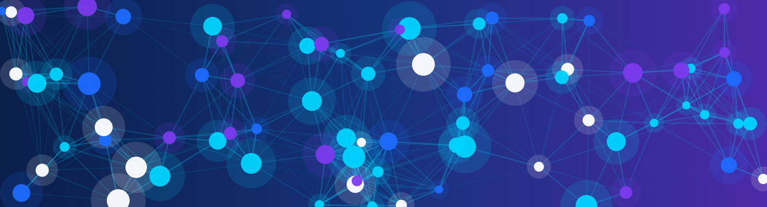
PART C

Hands-On Practice Lab
Learn by doing: activities, puzzles, prompt makeovers, verification tasks and a mini-project.
Section | What you will do
Classroom Activities | Five hands-on activities with live or simulated AI
Puzzles and Creative Challenges | Word search, cipher, hallucination hunt, 25-word prompt
Before-and-After Prompt Makeovers | Rewrite six weak prompts
Research Verification Activities | Sort sources, check claims, spot bias
Mini-Project | AI-assisted research report or creative presentation
Worksheet 3 and MCQ Bank | Applied questions and 20 multiple-choice questions

LIVE AI OR SIMULATED?
If your school allows an AI tool, run the live version using only fictional or public information. If not, every activity includes simulated AI answers so you can complete it offline.

Classroom Activities
Five hands-on activities. Work in pairs or teams as your teacher directs. Remember: no personal or confidential information in any prompt.

Activity 1: Prompt Makeover Lab
Goal | Time and grouping | Works offline?
Turn a weak prompt into a strong 5-part prompt and compare results. | 20 minutes, pairs | Yes (simulated outputs given)

- The weak prompt is: "Help me with my essay." List what is missing (role, context, format, example).
- Write an improved 5-part prompt for an essay on "Should schools teach AI skills?"
- Live: run both prompts. Offline: read the two simulated outputs below.
- Score each output from 1 (poor) to 5 (excellent) in the table.

Simulated output A (weak prompt) | Simulated output B (strong prompt)
Essays are important. To write an essay, make an outline, write the introduction, body and conclusion, then edit it. Good luck! | Outline: 1) Introduction: AI in daily life. 2) Argument for: jobs, creativity, safety awareness. 3) Argument against: cost, screen time, uneven access. 4) Conclusion: balanced policy. Suggested thesis: "Schools should teach AI skills, together with ethics and critical thinking."

Criterion | Output A (1-5) | Output B (1-5)
Clarity
Relevance to the task
Usefulness for my next step
Total (out of 15)

My improved prompt:
What difference did the extra details make?

Activity 2: Summarise and Compare
Goal | Time and grouping | Works offline?
Write your own summary, then check an AI summary against the original. | 25 minutes, individual then pairs | Yes (simulated AI summary given)

ORIGINAL TEXT (FICTIONAL)
Maple Road School, a fictional school, introduced a "Quiet Hour" in 2023: for 60 minutes every Wednesday, phones are switched off and students read, draw or work on projects. A teacher survey found that 8 of 10 teachers noticed better focus in the afternoon. Students were more divided: of 90 surveyed, 47 said they liked it, 28 were neutral and 15 disliked it. The principal says the school will keep the Quiet Hour for one more year and review it again with students' ideas.

Step 1: write three summaries yourself (no AI).
Summary type | Your summary
One sentence
Three bullet points
About 40 words

STEP 2: SIMULATED AI SUMMARY
Maple Road School's Quiet Hour has been a great success, with most students loving it and all teachers reporting better focus. The programme is now permanent.

Step 3: find the problems. Compare with the original. Tick the types of error you spot and explain.
Error type | Found? (Yes / No) | Explanation
Wrong or exaggerated detail
Added information not in the text
Missing important point

Activity 3: Idea Storm Relay
Goal | Time and grouping | Works offline?
Generate many ideas, then choose the best using criteria. | 30 minutes, teams of 4 | Yes (simulated AI list given)

Challenge: Plan a one-week AI Awareness Week for your school.
- Silent start (3 min): each member writes 3 ideas alone, without AI.
- AI boost: ask an AI tool for 10 more ideas, or use the simulated list below.
- Combine: merge similar ideas into a list of 6.
- Score each idea from 1 to 5 on three criteria; choose the highest total.
- Pitch: present the winner in 1 minute and say what you changed from the AI list.

SIMULATED AI IDEA LIST
1) AI-or-human quiz game 2) "Prompt of the day" board 3) Student panel on safe AI use 4) Poster contest 5) Fact-check challenge 6) Short skit on privacy 7) Lunch-break coding demo 8) Interview with a local engineer

Idea | Feasible (1-5) | Creative (1-5) | Impact (1-5) | Total
Our winning idea and one human improvement we added:

Activity 4: Poster Studio
Goal | Time and grouping | Works offline?
Plan a poster titled "Think Before You Prompt" using AI-style help and human decisions. | 35 minutes, pairs | Yes (planning canvas on paper)

Poster element | Your plan
Purpose and audience
3 headline options (ask AI or brainstorm)
Chosen headline and why
Image prompt (subject, style, mood, colours, space for text, avoid)
3 key points + the reliable source for each
Call to action
Credit line (AI help + sources)
Layout sketch (draw boxes for headline, image, key points, call to action, credit):

Activity 5: Privacy Traffic-Light Sort
Goal | Time and grouping | Works offline?
Sort prompts into Green (generally fine), Amber (think first) and Red (never share). | 15 minutes, pairs | Yes (paper cards)

Write G, A or R for each item, then rewrite two unsafe items safely.
# | Item typed into a public AI tool | G / A / R
1 | "How does a solar cell work?"
2 | Your full name together with your home address
3 | A photo of a friend's face to make a cartoon
4 | "Write a story about a fictional dragon."
5 | Your school Wi-Fi password
6 | A paragraph copied from a textbook, to be summarised
7 | A one-time password (OTP) sent to your phone
8 | Made-up sample marks to draw a chart
9 | A list of classmates' names with their exam scores
10 | Your school name, class and teacher's name in a prompt
11 | "Suggest 5 study tips for an Olympiad."
12 | A parent's bank card number
Rewrite two unsafe items safely:

Puzzles and Creative Challenges

Puzzle 1: Prompt Word Search
Find the 10 hidden words from Unit 5. Words can run right, left, down, up or diagonally down-right.
P | R | O | M | P | T | Z | K | W | O | H | R
D | R | A | F | T | R | N | Y | C | I | B | I
D | N | G | Y | R | A | M | M | U | S | R | P
G | T | X | E | T | N | O | C | V | Q | P | E
N | O | S | C | S | Q | V | L | E | Z | O | L
Q | R | I | R | I | M | H | P | R | Y | X | O
X | T | U | S | I | T | Q | R | I | U | U | R
L | A | Z | A | P | G | E | I | F | N | Z | I
K | M | T | I | D | C | J | V | Y | J | Z | S
I | R | K | B | B | U | L | A | T | G | R | Y
I | O | P | I | E | T | U | C | B | M | Q | W
R | F | F | K | F | C | D | Y | C | Q | I | D

Words to find
PROMPT | CONTEXT | FORMAT | VERIFY | SUMMARY
PRIVACY | DRAFT | BIAS | CITE | ROLE

Puzzle 2: Cipher Challenge
Three safety rules are hidden in a shift-by-3 code: each letter was replaced by the letter 3 places later in the alphabet (A becomes D, B becomes E, and so on; X, Y, Z wrap round to A, B, C). To decode, move each letter 3 places back.
Code | Decoded rule
FKHFN WKH VRXUFH
SURWHFW BRXU SULYDFB
FUHGLW DL KHOS
Bonus: Write a short safety rule of your own, encode it with the same shift, and swap with a partner to decode.

Puzzle 3: The Hallucination Hunt
A simulated chatbot produced this AI fact sheet. Some statements are correct and some are wrong. Mark each T (true) or F (false) and correct every false statement. Remember to verify using a reliable source!
# | Statement | T / F | Correction (if false)
1 | The term "artificial intelligence" was introduced in connection with a 1956 workshop at Dartmouth College.
2 | Alan Turing proposed his famous "imitation game" test in 1995.
3 | Python is a programming language widely used in AI; it was first released in 1991.
4 | Machine learning means that programmers write every rule by hand.
5 | Large language models learn patterns from large amounts of text.
6 | The capital city of India is Mumbai.
7 | A prompt is the input or instruction given to an AI tool.
8 | AI image generators never make mistakes in details.

Puzzle 4: Creative Challenges
CHALLENGE A: THE 25-WORD PROMPT
Your teacher needs a 5-slide outline on renewable energy for Class 9 students. Write a prompt of 25 words or fewer that includes at least four of the five parts (Role, Instruction, Context, Format, Example). Count your words!
My prompt:
Score yourself |  | Yes (1 point)
Contains at least 4 of 5 parts
25 words or fewer
A stranger could tell exactly what you want
Does not include personal information

CHALLENGE B: THE SIX-WORD STORY
Write a story in exactly six words about a student and an AI tool. Then add a one-line caption explaining what the story says about using AI wisely.

Before-and-After Prompt Makeovers
Rewrite each weak prompt so it includes as many of the five parts as makes sense (Role, Instruction, Context, Format, Example). Use the checklist after each one.
WORKED EXAMPLE
Before: "Tell me about water."
After: You are a geography teacher. Explain the water cycle to Grade 11 students in 5 bullet points, with one real-life example. If you are unsure of a fact, say so.
Why better: role, task, audience, format, example and an honesty request.

MAKEOVER 1 - BEFORE
"Summarise this." (A news article about a school sports day)
Your improved prompt:
Check: R ☐ I ☐ C ☐ F ☐ E ☐ Asked to flag uncertainty ☐ No personal data ☐
MAKEOVER 2 - BEFORE
"Make a poster."
Your improved prompt:
Check: R ☐ I ☐ C ☐ F ☐ E ☐ Asked to flag uncertainty ☐ No personal data ☐
MAKEOVER 3 - BEFORE
"Tell me about the French Revolution."
Your improved prompt:
Check: R ☐ I ☐ C ☐ F ☐ E ☐ Asked to flag uncertainty ☐ No personal data ☐
MAKEOVER 4 - BEFORE
"Write code for a calculator."
Your improved prompt:
Check: R ☐ I ☐ C ☐ F ☐ E ☐ Asked to flag uncertainty ☐ No personal data ☐
MAKEOVER 5 - BEFORE
"Give me ideas for a science fair."
Your improved prompt:
Check: R ☐ I ☐ C ☐ F ☐ E ☐ Asked to flag uncertainty ☐ No personal data ☐
MAKEOVER 6 - BEFORE
"Translate this."
Your improved prompt:
Check: R ☐ I ☐ C ☐ F ☐ E ☐ Asked to flag uncertainty ☐ No personal data ☐

Research Verification Activities

Activity A: Source Sorter
Rate each fictional source: R = Reliable, C = Use with caution (needs checking), U = Unreliable. Give a short reason using the C.H.E.C.K. method.
# | Source description | Rating | Reason
1 | A government statistics office table of rainfall data, with dates and a methods note
2 | An anonymous blog post titled "SHOCKING truth about AI that teachers hide!!!"
3 | A research paper in a peer-reviewed journal, with named authors and references
4 | A chatbot answer that includes a statistic but no sources
5 | A news article from an established newspaper with a named reporter, citing an official report
6 | An online encyclopaedia entry with a reference list at the bottom
7 | A company website claiming its AI tool is "100% accurate"
8 | A forwarded message saying "Send to 10 friends" with no source

Activity B: Claim Checker
A simulated chatbot wrote this about a fictional town. For each claim, decide what kind of claim it is and where you would verify it. (You cannot verify fictional facts, so write your plan.)
SIMULATED AI ANSWER: "PLASTIC WASTE IN RIVERVIEW" (FICTIONAL)
1) Riverview recycles 62% of its plastic waste. 2) Dr. Anil Menon said, "Recycling alone will never solve plastic pollution." 3) Plastic takes hundreds of years to break down. 4) A new city law bans all plastic bags from January 2025. 5) Everyone in Riverview agrees that plastic is the biggest problem.

Claim | Type (number, quote, general fact, law/date, opinion) | How I would verify it
1
2
3
4
5

Activity C: Spot the Bias
PROMPT: "DESCRIBE A TYPICAL SCIENTIST." SIMULATED AI ANSWER:
A typical scientist is a man in his fifties who wears glasses and works alone in a laboratory.

1. What is biased or stereotyped about this answer? (2 marks)
2. Rewrite the prompt to reduce bias. (2 marks)
3. Rewrite the answer in two sentences to be more accurate and fair. (2 marks)

Mini-Project: AI-Assisted Research Report or Creative Presentation
Show everything you have learned. Choose Option A or Option B and one topic (or get approval for your own).
 | Option A: Research report | Option B: Creative presentation
Product | 500 to 700 words with title, introduction, 3 sections, conclusion and sources | 6 to 8 slides with speaker notes and a sources slide
Must include | A chart or table; an AI-use note | A visual on every slide; an AI-use note
Sources | At least 3 reliable sources (AI alone does not count) | At least 3 reliable sources (AI alone does not count)

Topic ideas: (1) How can AI tools help our school reduce waste? (2) Is AI good for learning? Evidence for and against. (3) Safe social-media habits in the age of AI. (4) AI in healthcare: promises and risks. (5) AI and the environment. (6) Your own topic: ____________

Five-session plan
Session | Task | Done?
1 | Choose topic; write your research question; plan sub-questions (with or without AI)
2 | Collect information; summarise sources; fill in the Source Record
3 | Verify key claims with the C.H.E.C.K. method; fix any errors
4 | Draft the report or slides; use AI only as helper; keep the AI Use Log
5 | Edit, add the AI-use note and sources, proofread, present or submit

My AI Use Log
Prompt (no personal data) | Tool or simulated? | What I checked or changed

My Source Record
Source | Author or organisation | Date | Why reliable? | Claim I used

Assessment rubric (20 marks)
Criterion | Full marks look like... | Marks
Research and sources | 3 or more reliable, relevant sources; accurate information | /5
Prompting and AI log | Clear prompts, at least one revised; log complete | /4
Verification | Key claims checked; errors found and fixed | /4
Original thinking and voice | Own ideas and analysis; not just AI wording | /3
Structure and presentation | Logical, clear and well designed | /2
Responsible use | Privacy protected; honest AI-use note; credits given | /2
TOTAL |  | /20

REFLECTION (3-4 SENTENCES)
What did AI do well? What did you have to correct? What would you do differently next time?
Teacher feedback:

Worksheet 3: Prompting, Verification and Responsible Use
Name: | Class / Section: | Date:

Time: 40 minutes. Answer all 15 questions.
Section A: Multiple Choice 1 mark each
Q1. Which prompt is most likely to give a useful answer?
A. "Write about solar energy." | B. "Explain solar energy."
C. "You are a Grade 11 physics tutor. Explain how a solar cell works in 5 bullet points for 16-year-olds, with one everyday example." | D. "Solar energy please, long."
Q2. Lateral reading means:
A. Reading a page slowly from top to bottom | B. Opening other sources to check who is behind a claim
C. Reading text sideways | D. Reading only the headings
Q3. Which is a sign of an unreliable website?
A. A named author with expertise | B. Links to original data
C. A dramatic headline with no author and no sources | D. Contact details for the organisation

Section B: Fill in the Blanks 1 mark each
Q4. Giving the AI a sample of the style you want is called adding an ____________________ to the prompt.
Q5. The date at which an AI model's training data ends is called its knowledge ____________________.
Q6. Information that comes directly from the creator or data collector, such as a census table, is a ____________________ source.

Section C: True or False 1 mark each
Q7. Two independent reliable sources that agree make a claim stronger. True / False
Q8. It is fine to share a photo of your exam admit card with an AI tool so it can "read it out". True / False
Q9. A confident tone from an AI tool guarantees that the answer is accurate. True / False

Section D: Match the Following 1 mark each
Q10. Match each problem (left) with the best response (right).
Problem | Letter | Best response
1. Hallucination |  | a. Ask for several perspectives and check who is missing
2. Bias |  | b. Remove personal details before prompting
3. Privacy risk |  | c. Check the date and look for current sources
4. Outdated information |  | d. Use licensed or original material and give credit
5. Copyright concern |  | e. Verify with reliable sources

Section E: Short Answer
Q11. Write three verification steps you would follow before using an AI-provided statistic in a project. (3 marks)
Q12. Give one example where AI output could be biased and one way to reduce the effect. (2 marks)
Q13. Turn this vague request into a strong prompt: "Help me with my project." (Topic: water pollution in a fictional local river.) (3 marks)
Q14. Explain the difference between summarising a source and copying it. (2 marks)
Q15. Describe one situation where you should not use AI for schoolwork, and why. (2 marks)

Practice MCQ Bank
Choose the one best answer. Circle A, B, C or D. (20 questions; answers are in the Answer Key.)
Q1. Which feature is typical of a research-focused AI tool?
A. Generating a poster image | B. Showing linked sources for its answer
C. Translating a poem | D. Suggesting colour palettes
Q2. Large language models mainly work by:
A. Searching a perfect database of verified facts | B. Thinking exactly like humans
C. Predicting likely next words from patterns in training text | D. Copying whole web pages
Q3. Which prompt part tells the AI what shape the answer should take, such as a table or bullet list?
A. Format | B. Role
C. Context | D. Instruction
Q4. A prompt "Explain gravity" gets a college-level answer. Which addition fixes it best?
A. "Be harder" | B. "Tell me everything"
C. "Why gravity?" | D. "For a Class 8 student, in 100 words, with an everyday example"
Q5. Which is the strongest sign that a website may be unreliable?
A. It lists the author and date | B. It promises a "secret experts hide" and gives no sources
C. It links to original data | D. It has a contact page
Q6. Two independent, reliable sources report the same statistic. This:
A. proves nothing | B. means AI is always right
C. strengthens your confidence in the statistic | D. means you can stop checking all other claims
Q7. What is a knowledge cutoff?
A. The point after which the model's training data has no new information | B. The date a tool stops working
C. A limit on prompt length | D. A school rule on AI use
Q8. Which step belongs in prompt revision?
A. Delete the tool | B. Always make prompts longer
C. Never test the prompt | D. Compare the output with your goal and edit the prompt accordingly
Q9. Asking a chatbot "Are you sure?" and getting "Yes" shows:
A. the fact is correct | B. nothing certain; you still need to verify
C. the source definitely exists | D. the AI has checked the web
Q10. Which is a privacy-safe way to ask for help writing a letter?
A. Use placeholders such as [Student Name] and [School] | B. Include your full name and address
C. Add your parent's phone number | D. Upload a photo of your ID
Q11. Bias in AI output can come from:
A. only the user's mood | B. only a slow internet connection
C. training data, design choices and the way a prompt is worded | D. only the size of an image
Q12. Which statement about copyright is most accurate?
A. Facts and ideas are protected in exactly the same way as art | B. Anything online is free to copy
C. AI output is copyright-free everywhere | D. Copyright protects original expression, so use permitted material and give credit
Q13. In the "AI sandwich", who makes the final decisions?
A. The human | B. The AI tool
C. The tool's company | D. The first search result
Q14. Which is a good use of AI in debate preparation?
A. Reading an AI-written speech unedited | B. Copying another team's speech
C. Generating arguments for both sides, then judging the evidence yourself | D. Skipping research because AI sounds confident
Q15. Why add "If you are unsure, say so" to a prompt?
A. It makes the tool 100% accurate | B. It encourages the tool to show uncertainty so you know what to check
C. It stops the tool using words | D. It hides mistakes
Q16. An AI poster image shows the misspelt word "Scince". What is the best fix?
A. Leave it because AI made it | B. Call it "creative spelling"
C. Delete the whole project | D. Correct the spelling in an editing tool and proofread the whole poster
Q17. Which is a primary source?
A. An original interview transcript recorded by the researcher | B. A magazine summary of the interview
C. A student's notes on the magazine | D. A chatbot's description of the interview
Q18. Which action is part of lateral reading?
A. Reading the same article twice | B. Judging only by page design
C. Opening new tabs to find out who runs the website | D. Trusting the "About" page alone
Q19. Which is the most responsible way to chart survey data with AI?
A. Upload classmates' names and marks | B. Use anonymous or fictional data, check the chart against the numbers and label the source
C. Trust the chart without checking | D. Remove axis labels to look cleaner
Q20. Which statement about free AI tools is true?
A. They never need accounts | B. They never store anything
C. They are always allowed in exams | D. Features, limits and age rules can change, so check current terms and school rules

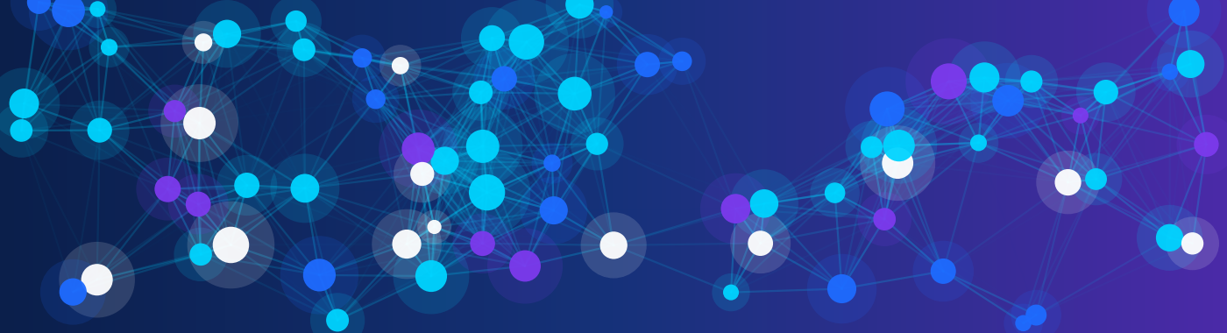
PART D

Review and Assessment
Revise, test yourself and check your answers.
Section | What is inside
Quick Revision Quiz and Concept Map | Ten rapid questions and a concept map to complete
Chapter Summaries | The key points of Chapters 1 to 9
Glossary | 33 key terms
Assessment (30 Marks) | A full test with a clear marking scheme
Answer Key | Answers to every worksheet, activity, puzzle and the assessment

HOW TO REVISE
First try everything without the answer key. Then mark your work, note mistakes and rewrite weak answers. Mistakes are the fastest way to learn.

Quick Revision Quiz and Concept Map
Answer in one line each (1 minute per question).
# | Question | My answer
1 | Name any four categories of AI tools.
2 | What does the R in the 5-part prompt stand for?
3 | What does LLM stand for?
4 | Give one sign that an AI answer may be a hallucination.
5 | Name one way to reduce bias in a prompt.
6 | What should you use instead of real names and addresses in a prompt?
7 | What does the first C in C.H.E.C.K. stand for?
8 | Is a blog post with no author and no sources a reliable source? (Yes / No)
9 | In the prompt loop, which step comes right after Test?
10 | Who is responsible for the final accuracy of an AI-assisted project?

Concept map: complete it
Fill each dashed box with a key idea from the unit. Then add two cross-links (arrows with a short label) between the two branches, for example one idea that connects both.
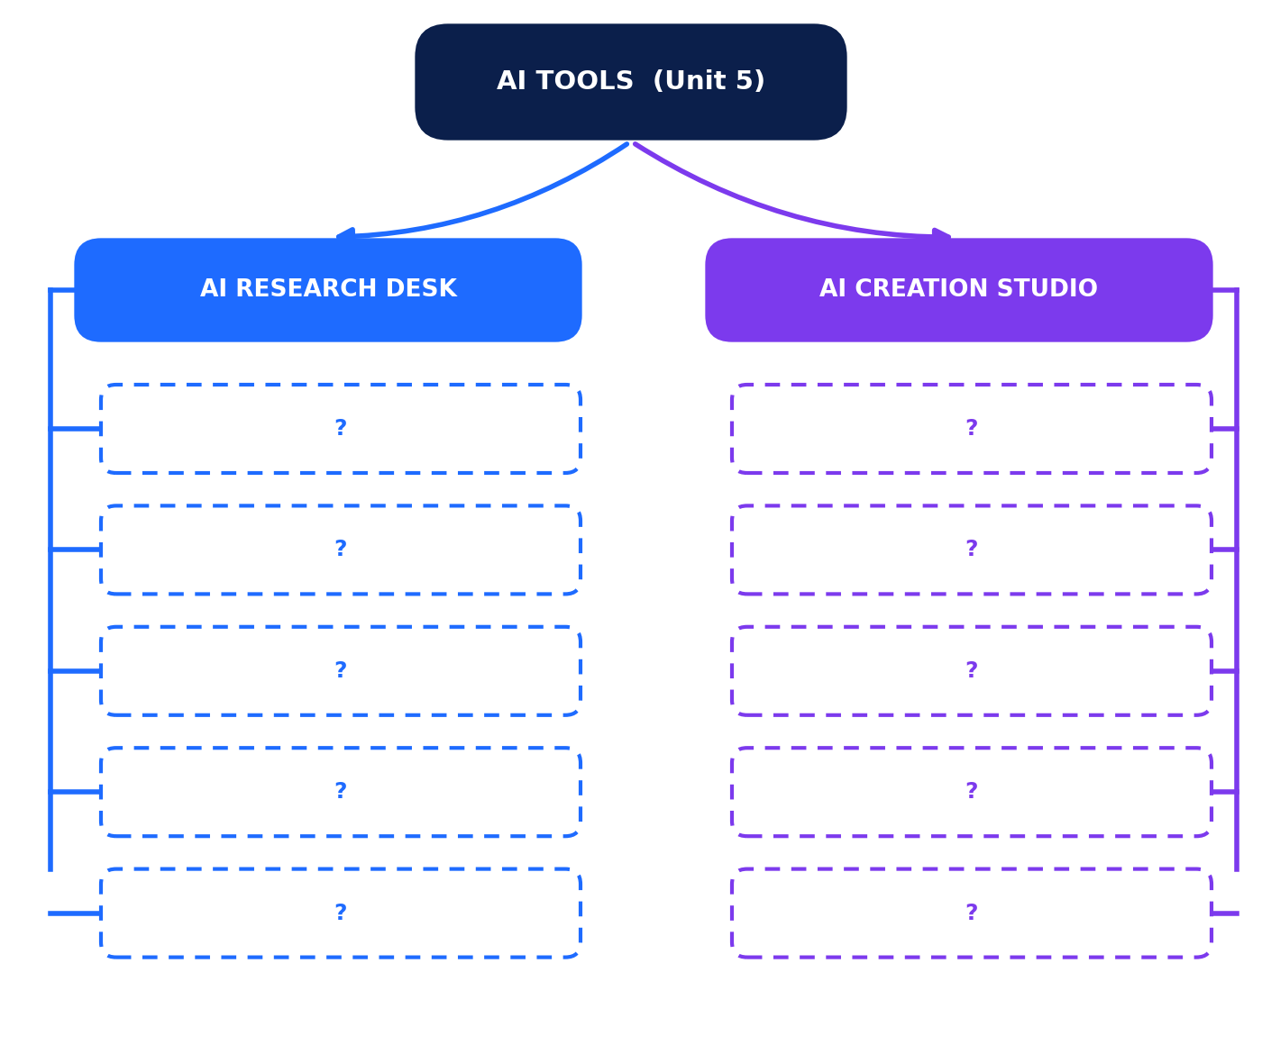
Figure D.1: Concept map to complete. Compare with the model in the Answer Key.

Chapter Summaries
Chapter | Key points
Ch 1 Introduction to AI Tools | AI tools use machine learning to perform tasks such as writing, summarising, translating, creating images, coding and analysing data. Nine categories cover most school uses. Chatbots predict likely words, so fluent does not mean correct. Tool availability varies.
Ch 2 AI as Your Research Partner | AI supports research, brainstorming, learning and problem-solving, but it is an assistant, not an authority. Use the six-step workflow: define, ask, summarise, verify, organise, create and cite.
Ch 3 Writing Effective Prompts | Strong prompts include Role, Instruction, Context, Format and Example. Improve prompts by writing, testing, evaluating and revising. Ask the tool to flag uncertainty.
Ch 4 Summarising and Organising | Choose the right kind of summary and always compare it with the original. Organise notes by collecting, clustering, labelling, ordering and finding gaps. Brainstorm by diverging, then converging with criteria.
Ch 5 Verifying AI Output | Watch for hallucinations, outdated facts, slips, bias and fake citations. Use C.H.E.C.K., lateral reading and reliable sources. Respect copyright, give credit and know the limits of AI.
Ch 6 Safe and Responsible Use | Keep personal and confidential information out of prompts, use placeholders and approved tools, protect accounts, respect others, be honest about AI use and know when not to use AI.
Ch 7 Creative AI Tools | Generative AI makes text and images. Write precise image prompts (subject, setting, style, mood, colours, composition, avoid), edit AI drafts in your own voice and check every image.
Ch 8 Posters and Presentations | Plan with one clear message and a storyboard. Use AI for options and drafts. Apply design principles, check facts and add credits and alt text.
Ch 9 Human Creativity Plus AI | Use the AI sandwich: you decide, AI assists, you refine and verify. Keep your own voice, log your process and disclose AI use honestly.

Glossary
Term | Meaning
AI tool | Software that uses artificial intelligence to perform tasks such as writing, translating or analysing data.
Alt text | A short written description of an image for people who cannot see it.
Anonymous data | Information collected without names or details that identify a person.
Attribution (credit) | Naming the source or creator of work you use.
Bias | Systematically unfair or one-sided output or behaviour.
Brainstorming | Generating many ideas before choosing the best.
C.H.E.C.K. method | Cross-check, Honest author, Evidence, Current, Know the purpose.
Context (in prompts) | Background that tells the AI who the answer is for and what you already know.
Copyright | Legal protection for original creative work.
Creative Commons | A set of licences that lets creators share work with stated conditions.
Deepfake | A fake image, audio or video made with AI to look real.
Disclosure | Honestly stating when and how AI helped.
Format (in prompts) | The shape of the desired answer, e.g. bullets, table or word limit.
Generative AI | AI that creates new content such as text, images or audio.
Hallucination | Confident AI output that is false or invented.
Image prompt | A written description used to generate a picture.
Knowledge cutoff | The date after which a model's training data has no new information.
Large language model (LLM) | An AI model trained on large amounts of text to predict and generate language.
Lateral reading | Opening other sources to check who is behind a claim.
Personal information | Details that identify a person, such as name, address or ID numbers.
Placeholder | A stand-in such as [Student Name] used instead of real details.
Plagiarism | Presenting someone else's work or words as your own.
Primary source | A first-hand record, such as original data or an interview.
Prompt | The instruction or question given to an AI tool.
Prompt refinement | Improving a prompt by testing, evaluating and revising it.
Role (in prompts) | Who you want the AI to act as.
Secondary source | A source that explains or analyses primary sources.
Storyboard | A plan showing the order of slides or scenes.
Summarisation | Condensing information into its key points.
Transcription | Converting speech to written text.
Verification | Checking a claim with reliable sources.
AI sandwich | Human idea, then AI assistance, then human review and decision.
AI-use note | A short statement describing how AI was used in your work.

Assessment (30 Marks)
Name: | Class / Section: | Date:

Time | Total marks | Instructions
45 minutes | 30 | Answer all questions. Write clearly. Do not use AI tools during the assessment unless your teacher says so.

Section A: Multiple Choice 8 marks (1 each)
1. A student wants a tool that turns a recorded lecture into written notes. Which category fits best?
A. Image generator | B. Presentation creator
C. Transcription or productivity tool | D. Coding assistant
2. In the prompt "Act as a museum guide. Describe the Taj Mahal for children aged 10 in exactly 100 words", which phrase gives the ROLE?
A. Describe the Taj Mahal | B. Act as a museum guide
C. for children aged 10 | D. exactly 100 words
3. Why should you compare AI output with a reliable source?
A. AI never works | B. Sources are always longer
C. Teachers prefer long answers | D. AI can produce confident but incorrect statements
4. A student asks AI about a recent sports final and gets an answer. What is the best move?
A. Check a current, reliable source, because the tool's knowledge may be out of date | B. Trust it because AI always has live data
C. Ask the AI to repeat it more firmly | D. Ignore sports information
5. Which is the most appropriate thing to include in a prompt to a public AI tool?
A. Your national ID number | B. Your parents' bank details
C. The backstory of a fictional character | D. Your home Wi-Fi password
6. A chatbot uses only male examples for every scientist and leader, whatever you ask. This most likely shows:
A. hallucination | B. bias
C. encryption | D. compression
7. Which is the best step after you notice an AI answer is vague?
A. Accept it | B. Delete the tool
C. Ask a friend to do the task | D. Revise the prompt with more context and format
8. Which statement about AI-assisted creative work is TRUE?
A. Human review, editing and disclosure keep the work honest and original | B. The human is no longer responsible
C. Copyright rules no longer apply | D. AI always cites its sources correctly

Section B: Fill in the Blanks 4 marks (1 each)
9. A reliable source usually shows a named ____________________ and a publication date.
10. To protect privacy, remove ____________________ details such as names and phone numbers before sending a prompt.
11. Tools that predict and produce human-like text are built on ____________________ language models.
12. Telling readers that AI helped create your work is part of ____________________ use of AI.

Section C: True or False 4 marks (1 each)
13. AI tools are always up to date with the latest news. True / False
14. Asking AI for multiple perspectives can help reduce one-sided answers. True / False
15. Paraphrasing a source without mentioning it is acceptable in a school report. True / False
16. All AI tools are free and need no account. True / False

Section D: Match the Following 4 marks (1 each)
17. Match each term (left) with its meaning (right).
Term | Letter | Meaning
1. Prompt |  | a. Systematically unfair output
2. Hallucination |  | b. Checking claims with reliable sources
3. Bias |  | c. The instruction given to an AI tool
4. Verification |  | d. Confident output that is false or invented

Section E: Short Answer 10 marks
18. Name and explain three components of an effective prompt, giving a short example for each. (3 marks)
19. A student's AI-generated report includes a quote attributed to a scientist but gives no source. List three steps to verify it. (3 marks)
20. Describe how a student could combine human creativity with AI to prepare a presentation on "Safe Use of AI". Mention at least two human tasks and two AI tasks. (4 marks)

Answer Key
USING THE KEY
Open-ended answers are suggestions. Accept any reasonable answer that meets the marking points. Fictional facts in activities cannot be verified; assess the student's verification plan.

Worksheet 1: AI Research Desk
Q | Answer
1-4 | Q1 B (Summarisation); Q2 A (Role); Q3 C (check a reliable source); Q4 C (a general study question)
5-7 | Q5 hallucination; Q6 refinement (revision or iteration accepted); Q7 bias
8-10 | Q8 True; Q9 False (references and DOIs can be invented, so open and check them); Q10 True
11 | 1-d, 2-c, 3-b, 4-e, 5-a
12 | Any three (1 mark each): suggest keywords and sub-questions; explain concepts simply; summarise long texts; organise notes into themes; brainstorm angles; translate sources; check reasoning steps.
13 | Sample: "You are an environmental science teacher. Explain the main causes of climate change to Class 11 students in 5 bullet points, using simple words and one real-life example. Say if any fact is uncertain." (1 mark each for role, context/audience, format)
14 | 1 mark: it is private information and the classmate has not given permission. 1 mark: online tools may store or share it, which could cause harm or embarrassment.

Worksheet 2: AI Creation Studio
Q | Answer
1-3 | Q1 B; Q2 C; Q3 B
4-6 | Q4 prompt; Q5 disclosing (crediting or acknowledging accepted); Q6 storyboard
7-9 | Q7 True; Q8 False; Q9 True
10 | 1-c, 2-d, 3-e, 4-b, 5-a
11 | Advantages (any two): quick ideas and visual options; saves drafting time; helps with layout. Limitation (one): possible errors or bias; needs human checking; may lack originality. (1 mark each)
12 | Sample: "A friendly robot protecting a glowing padlock beside three students, flat vector style, calm and trustworthy mood, navy, cyan and violet colours, empty space at the top for a title, no text or logos." (1 mark each: subject and style; mood and colours; space for text)
13 | Not correct. AI output may resemble existing work; rules about ownership vary by country and tool terms; you must still check permissions, credit sources and follow school policy. (2 marks)
14 | Any specific, realistic method: rewrite in own voice; add a personal or local example; restructure; combine with own sketches or research. (2 marks)

Worksheet 3: Prompting, Verification and Responsible Use
Q | Answer
1-3 | Q1 C; Q2 B; Q3 C
4-6 | Q4 example; Q5 cutoff; Q6 primary
7-9 | Q7 True; Q8 False; Q9 False
10 | 1-e, 2-a, 3-b, 4-c, 5-d
11 | Any three: find the statistic in a reliable primary source; check author or organisation and date; compare with a second independent source; confirm that numbers and wording match.
12 | Example: an image generator shows only men as engineers. Reduce: ask for diverse examples, check who is missing, compare with several reliable sources. (1 mark each)
13 | Sample: "You are an environmental science teacher. Help me plan a project on water pollution in a fictional local river. Give 5 research questions and a 3-part outline for a Class 11 report as a numbered list, and tell me which facts I should verify." (3 marks: role, context/format, verification request)
14 | Summarising restates the main ideas in your own words, more briefly, and credits the source. Copying uses the exact words or ideas without credit, which is plagiarism. (2 marks)
15 | Example: when the task is to practise a skill (solving problems, in-class writing) or when rules forbid AI. Using AI would defeat the purpose of learning. (2 marks)

Practice MCQ Bank (20 questions)
Q | Answer | Q | Answer
1 | B | 11 | C
2 | C | 12 | D
3 | A | 13 | A
4 | D | 14 | C
5 | B | 15 | B
6 | C | 16 | D
7 | A | 17 | A
8 | D | 18 | C
9 | B | 19 | B
10 | A | 20 | D

Activities (suggested answers)
Q | Answer
Act 1 | Missing: role, audience and context, length, format, example. Sample improved prompt: "You are a Class 11 English teacher. Help me plan an essay on 'Should schools teach AI skills?' for my classmates, about 500 words. Give a thesis, three arguments for and two counter-arguments in a numbered list." Expected scores: A about 2/1/1; B about 5/5/4.
Act 2 | Errors in the AI summary: "most students loving it" (47 of 90 liked it; 28 were neutral; 15 disliked); "all teachers" (8 of 10); "now permanent" (only one more year, then review). Missing: students' mixed views and the review. Sample one-sentence summary: "A weekly Quiet Hour improved focus for most teachers, students' opinions were mixed, and the school will continue it for one year before reviewing."
Act 3 | Marks for a scored table, a justified winner and a stated human improvement (e.g. changing the idea to suit the school timetable).
Act 4 | Marking points: one clear message; image prompt with at least five elements; each key point has a reliable source; sketch shows hierarchy; credit line mentions AI help and sources.
Act 5 | Green: 1, 4, 8, 11. Amber: 3, 6, 10. Red: 2, 5, 7, 9, 12. Safe rewrites: #2 "Write a letter to a municipal officer about a broken streetlight using [Name] and [Address] placeholders." #9 "Create a table of 5 fictional students with random marks and calculate the class average."

Puzzles
Puzzle 1: word search positions (row and column counted from the top-left, starting at 1):
Word | Location
PROMPT | row 1, column 1, going right
CONTEXT | row 4, column 8, going left
FORMAT | row 12, column 2, going up
VERIFY | row 4, column 9, going down
SUMMARY | row 3, column 10, going left
PRIVACY | row 6, column 8, going down
DRAFT | row 2, column 1, going right
BIAS | row 10, column 4, going up
CITE | row 5, column 4, going diagonally down-right
ROLE | row 7, column 12, going up

Q | Answer
Puzzle 2 | CHECK THE SOURCE; PROTECT YOUR PRIVACY; CREDIT AI HELP
Puzzle 3 | 1 True; 2 False (1950); 3 True; 4 False (machine learning learns patterns from data; not every rule is hand-written); 5 True; 6 False (New Delhi); 7 True; 8 False (they can make mistakes in details).
Puzzle 4A | Sample (21 words): "As a science teacher, outline five slides on renewable energy for Class 9, with simple words and one example per slide." Has role, instruction, context, format.
Puzzle 4B | Sample: "Asked AI. Checked. Learned. Wrote myself." Caption: AI helps best when I stay in charge. Accept any exactly six-word story.

Before-and-after prompt makeovers (sample answers)
Q | Answer
1 | "You are an editor. Summarise the attached news article about a school sports day in 3 bullet points for Class 11 students, then write a one-line headline. Do not add facts that are not in the article."
2 | "You are a graphic designer. Plan a poster for a school recycling drive for students aged 14 to 17: suggest a headline, 3 key points, a green and navy palette and a layout, as a numbered list. Leave space for a QR code."
3 | "You are a history teacher. Explain the main causes of the French Revolution to Class 11 in 6 bullet points, each with one example, then a 2-line summary. Flag any date you are unsure about."
4 | "You are a Python tutor. Write a beginner-friendly calculator program that adds, subtracts, multiplies and divides two numbers and handles division by zero. Add comments, then explain how to test it."
5 | "You are a science-fair mentor. Suggest 8 project ideas for Class 11 students with a budget under ₹500 and one week to prepare. For each, give a one-line method and what to measure, in a table."
6 | "You are a professional translator. Translate the paragraph below from English to Hindi in a simple, friendly tone for Class 6 students. Keep names unchanged and list any words you are unsure about. [paragraph]"

Research verification activities
Q | Answer
A: Sorter | 1 R (official data, methods shown); 2 U (anonymous, sensational); 3 R (peer-reviewed); 4 U until verified (no sources); 5 R (still cross-check key facts); 6 C (good starting point, follow references); 7 C (promotional, biased); 8 U (no source, pressure to share).
B: Claims | 1 Number: check the municipal or environment department report. 2 Quote: find the original talk or publication and check that Dr. Menon exists and said it. 3 General fact: check a science textbook or environment agency; estimates vary by plastic type. 4 Law or date: check the official gazette or city council site. 5 Opinion and over-generalisation: "everyone" is a red flag; look for survey data.
C: Bias | 1 It assumes a scientist is a man in his fifties working alone (gender, age and work stereotypes). 2 "Describe the range of scientists and the work they do, including different backgrounds and teamwork." 3 "Scientists come from all genders, ages and backgrounds. Many work in teams in labs, in the field or at computers."

Case studies (suggested answers)
Q | Answer
CS 1 | 1 Any two: planning sub-questions; explaining a concept; experiment design; making a chart. 2 A hallucinated citation: she searched, could not find it, dropped the claim and used a textbook. 3 Anonymous codes; no classmates' names or photos typed into tools. 4 Compare with a second reliable source; check the author and date; ask a teacher or librarian.
CS 2 | 1 Shortlisting and combining slogans, editing images, designing an original mascot, writing the credit line. 2 They noticed the lack of diversity and rewrote the prompt to show a mix of students. 3 Copying a character could break copyright and would not be original; designing their own is fairer and more creative. 4 Proofread everything, fact-check, check readability and get teacher approval.

Quick revision quiz
Q | Answer
1 | Any four: research, writing, summarising, translation, image generation, presentation creation, coding, data analysis, productivity
2 | Role
3 | Large language model
4 | A confident fact, quote or reference that cannot be found in reliable sources
5 | Ask for several perspectives, or use neutral wording
6 | Placeholders, such as [Student Name]
7 | Cross-check
8 | No
9 | Evaluate
10 | The human (the student)

Assessment: answers and marking scheme (30 marks)
Section | Answers | Marks
A (Q1-8) | Q1 C; Q2 B; Q3 D; Q4 A; Q5 C; Q6 B; Q7 D; Q8 A | 8
B (Q9-12) | Q9 author; Q10 personal (identifying also accepted); Q11 large; Q12 responsible (ethical or honest accepted) | 4
C (Q13-16) | Q13 False; Q14 True; Q15 False; Q16 False | 4
D (Q17) | 1-c, 2-d, 3-a, 4-b | 4
E Q18 | 1 mark each for naming and explaining a component with an example: Role, Instruction, Context, Format or Example | 3
E Q19 | 1 mark each for a valid step: search for the original quote or source; check the scientist exists and is an expert; compare with two reliable sources; look at publication and date; ask the tool for its source and then check it | 3
E Q20 | 1 mark each for two human tasks (choose message, fact-check, design decisions, edit tone, present) and 1 mark each for two AI tasks (draft outline, suggest slide order, suggest images, offer rewordings) | 4
TOTAL |  | 30

Model concept map
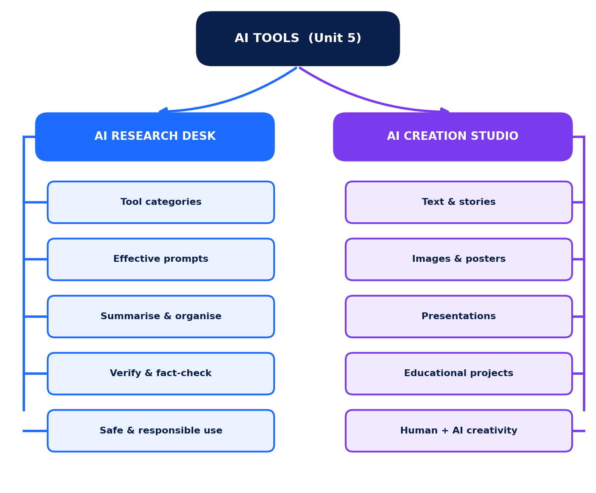
Figure D.2: A model concept map. Cross-links might include "verification" linking Research Desk and Creation Studio.

